A Practical Guide
to
Observation, Assessment
and Planning
in the
Early Years Foundation Stage

Introduction
‘Documentation is not about what we do but what we are searching for’ Carla Rinaldi.
Effective Observation, Assessment and Planning (OAP) is key to providing enabling environments where children can grow, thrive and develop; supported by adults who know and understand how individual children play, learn and make progress.
The Early Years Foundation Stage (EYFS) Statutory Framework (September 2017) states:
• Practitioners must consider the individual needs, interests, and stage of development of each child in their care, and must use this information to plan a challenging and enjoyable experience for each child in all of the areas of learning and development. (EYFS 1.6)
• Each area of learning and development must be implemented through planned, purposeful play and through a mix of adult-led and child-initiated activity.
(EYFS 1.8)
• In planning and guiding children’s activities, practitioners must reflect on the different ways that children learn and reflect these in their practice. (EYFS 1.9)
• The key person must help ensure that every child’s learning and care is tailored to meet their individual needs. (EYFS 1.10)
• Assessment should not entail prolonged breaks from interaction with children, nor require excessive paperwork. Paperwork should be limited to that which is absolutely necessary to promote children’s successful learning and development. (EYFS 2.2)

The OAP Cycle
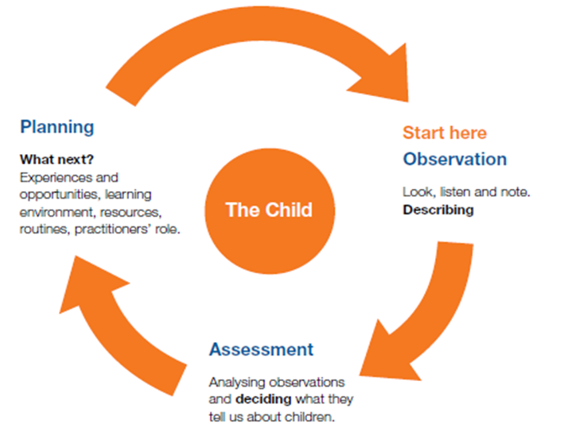

Ofsted
Ofsted say those working in schools and settings are best placed to make the important decisions about how children learn. However, Ofsted does define the elements of early year’s practice that make up teaching, so that there is a common ground and degree of transparency when making judgements about the quality of teaching.
Teaching should not be taken to imply a ‘top down’ or formal way of working. It is a broad term which covers the many different ways in which adults help young children learn’. OFSTED

It includes their interactions with children during planned and child-initiated play and activities:

- communicating and modelling language
- showing
- explaining
- demonstrating
- exploring ideas
- encouraging

- questioning
- recalling
- providing a narrative for what they are doing
- facilitating
- setting challenges.

It takes account of:
- the equipment provided
- the physical environment
- the structure and routines of the day that establish expectations.
Integral to teaching is how practitioners assess what children know, understand and can do as well as take account of their interests and dispositions to learning (characteristics of effective learning), and use this information to plan children’s next steps in learning and monitor their progress. (taken from Ofsted ‘Teaching and Play in the Early Years- a balancing act? July 2015)
Paperwork – What is absolutely necessary?
Ofsted do not advocate a particular method of planning (including lesson planning), teaching or assessment; it is up to schools to determine their practices and it is up to leadership teams to justify these on their own merits. (taken from pg. 13 school inspection handbook)

Before you start – some things to consider
Observation, assessment and planning is an ongoing process which all staff who work directly with the children need to be involved in. It is a dynamic process which will evolve and change over time depending on the current needs of your setting or school and the understanding of the staff about how young children learn.
Ask yourself ‘Is our current OAP practice successful?’ i.e.….
The templates included in this booklet are intended as a starting point to support observation, assessment and planning. They are word documents which can be adapted and developed to suit the needs of the practitioners. They are not required formats to be used in Oxfordshire but are simply a selection of examples that may support you in the process of observation, assessment and planning.
For more in depth support, consider our training packages around observation, assessment and planning in the Early Years available through our Step into Training programme.
 | In place? | Even better if….
All staff are familiar with the requirements of the EYFS regarding OAP
An OAP policy is in place
Staff have considered the ethics of OAP including the rights of the child
Parents are made aware of how the setting will collect, record and share information about their child and have given their permission
Staff are aware of safe storage of information
All staff are aware of data protection legislation and the organisation is registered with the ICO
https://ico.org.uk/for-organisations/register/faqs
Children and parents are able to access Learning journeys and can contribute to them
Staff are confident in using the information gathered to improve provision for the individual child and the setting as a whole

‘Starting with me’
Finding out about and meeting the needs of the ‘Unique Child’
What do you do to recognise, understand and meet each child’s individual needs? Central to this is the role of the Key Person.
The EYFS states:
Each child must be assigned a key person (also a safeguarding and welfare requirement - see paragraph 3.27). Providers must inform parents and/or carers of the name of the key person, and explain their role, when a child starts attending a setting. The key person must help ensure that every child’s learning and care is tailored to meet their individual needs. The key person must seek to engage and support parents and/or carers in guiding their child’s development at home. They should also help families engage with more specialist support if appropriate.
Their role is to help ensure that every child’s care is tailored to meet their individual need,
to help the child become familiar with the setting, offer a settled relationship for the child and build a relationship with their parents.
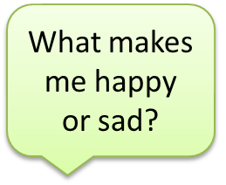
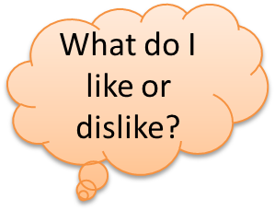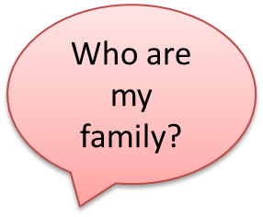

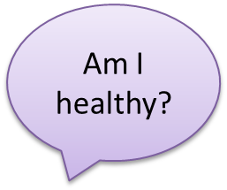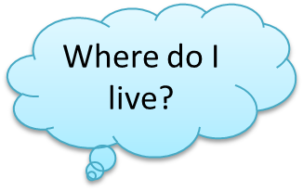

- Discussions with parents
- Discussions with the child
- Discussions between practitioners
- Observing the child when they are in their familiar environment – home visits, visits to current setting
- Information from the child’s previous setting

- Two year check
- On entry/initial assessments/starting points
- Regular observations
- Observations across the 7 areas of learning
- Observations of characteristics of learning
- Observations in a range of context e.g. inside/outside

Possible ways of collecting information for observation, assessment and planning
Longer/Narrative Observations Children assessed by an adult, references made to Development Matters and Characteristics of Effective Learning. Dated. Next steps noted. Learning stories.

Short/Anecdotal observations/magic/ wow moments May be written on self- adhesive labels, post its, and related to DM. Dated. Must inform planning. Information can then be transferred into individual children’s records.

Self-Assessments (child’s input) Pictures, writing, transcripts and photographs are used as evidence of achievement. Adults talk about evidence (learning journeys/evidence folders) with the child and encourage them to discuss their thoughts.

Group Observations and Transcripts
Making notes and comments and actions of individual children and interactions between groups

Annotated examples of work Paintings, drawings or pieces of writing – with additional information recorded by the adult on date, context, the learning objective of the activity the child was involved in and significant points noted about what the child said or did

Photographs/Video Clips/Recordings
Photographs (including use of digital camera), taped recordings, videos of work, must be dated

Evidence –
Observable feature or something child has said

Adult Focused Activities
Planned activities for individual children or a group of children. Assessments made by adult of how children responded to activity and what they learnt from it. Dated. Next steps recorded.

Check Lists Dated records of achievements. Eg phonic sounds and letters; numbers etc
Learning Journey, Evidence Folder, Writing/Maths book Achievements which can be shared between child, parent/carers and teachers. Contains all of the above

Timed Observations - Tracking
Observations about what activities a child is involved in or how they interact with others can be made over a session at regular intervals, e.g. every 5 minutes or 30 minutes. Usually helpful for children of concern

Parents/Carers input and evidence Parental contributions, e.g. Wow slips, All About Me sheets

A guide to observations
- Anecdotal/magic moments/post-its/short observations
The briefest observations that you can make are usually captured on ‘post-it’ notes, sticky labels or electronically, which can be easily put into a learning journey/developmental folder. This is the quickest way to record an observation and usually the most convenient for practitioners. Practitioners should note anything that is a ‘first’, e.g. the first time climbing steps unaided and also anything particular to that child. Practitioners who know their children well will be able to note anything unusual or exceptional about the child’s play at that moment. The aim of this type of observation is to build a picture about the children’s interests and development from many pieces of information. These can be done by any adult but it is the key person who will know if the observation is a new achievement by the child.
- Long observation/ Narrative
The narrative observation, sometimes called a ‘long’ observation, is an extended written account of an activity. It should include a verbatim record of any language used by the child, level of involvement and other children that they play with, and may also include a photo. Ideally the child’s key person should record a narrative observation, as he or she is most likely to understand the context of the play. The practitioner usually observes the child for 5 to 10 minutes, so as much information as possible can be recorded. As this method takes longer, and is much more detailed than a short observation, it is used less frequently. This is a good method to use as the child initially starts in the setting as it gives a lot of information quickly. The narrative observation may be planned in advance to ensure that every child in the nursery is observed in this way once every half-term, for example. However this must be fairly flexible in order to obtain useful information when a child is engaged in interesting play.
- Learning stories
Learning stories are longer observations, made over a much longer period of time. They are based on the child’s interests, their level of involvement, persistence, communication and taking responsibility. They are written as a story in the first person, as if the practitioner were talking to the child and explaining what they had observed. Examples of these may be an extended record of how a child got out the paints, chose a particular paintbrush and carefully composed a self-portrait. The relevance of each step is explained and reflected on at the end of the ‘story’. These are illustrated with photographs. Care must be taken not to simply annotate the photographs but to produce a reflective, thoughtful story to accompany them. Parents or carers are encouraged to add their own comments at the end of the learning story.
This observational method takes a bit longer than the short observations or narrative, but gives a really personal dialogue between child, practitioner and parents. It is particularly valuable for children who are just starting at nursery or for boosting self-esteem.
- Time sample
In a time sample observation, an observation of a child is made every five minutes over a set period of time, usually an hour. The observations are brief, but will include the activity the child is engaged in; which area of the nursery they are in and the level of involvement at that particular time. The practitioner will need to make the observations regularly, which can be a challenge in a free flow environment. Each observation will take less than a minute to record.
This type of observation is useful for recording a child’s level of interest in types of activities, and their disposition. For example, it may become obvious from this sort of observation that the child spent an hour in different parts of the nursery, but always doing construction activities; or that a child never engaged in writing activities, even though he or she played in several areas that had writing opportunities.
- Tracking
To record a tracking observation you must first have a floor plan of the setting, including outdoors. The practitioner observes and notes on the floor plan the area in the nursery that their child visits, and how long they were at each activity or area. The child may be tracked for a long or short time, depending on the type of information required. For example, if the observation is to help understand why a child seems to flit from activity to activity, the practitioner could observe for the morning session. The observations may show from this that the child is, in fact, transporting items from one area of the nursery to another, because he or she has a transporting schema.
The tracking observations of all the children can be collated, to analyse the areas of the nursery that are being used by certain groups of children. For example, is it always the girls that access the book corner? Do the younger children tend to use the sand more than the older ones?
- Sociogram
A less well-used observational technique is the sociogram. These are observations of the social groups that children play in. The practitioner observes the children that their focus child is playing with, what they are playing and for how long. When the child plays with different children, or changes activities with the same children, this is noted.
This observational technique can be used throughout the nursery, so the growing social development of the child can be observed and tracked.
Some children will play with a close social group all day, whereas others will move easily between groups. Occasionally some children seem not to play with anyone, but on closer observation you may find they actually have a large social circle, but only spend time briefly with each of their friends. This information can give a very powerful image of the child’s social groups and social competence.

Choosing a technique
The choice of observational technique will depend on the time practitioners have available and the reason for making the observation. Each method requires the practitioner to have an observational skill set. Ironically, the most skill is required to complete the shortest observation, the magic moment. This is because the practitioner must recognise the moment to begin with, and then record it quickly, succinctly and accurately.
It may be worth considering starting less experienced practitioners on a tracking or sociogram method until they are confident in recording observations. It is essential to use a range of methods, so practitioners can get a breadth and depth of knowledge about the children in their care. Similarly, different practitioners will observe based on their own experiences, recording different aspects of children’s development. For example, a practitioner who has training in children’s physical development is more likely to record observations of motor skills whilst someone who is trained in language development may record more of the children’s conversations. By using close observation of children, practitioners can reveal a wealth of information, from interests to social group to dispositions.

What makes a good learning journey?
The following ideas are not intended as a checklist but as a starting point for discussion with practitioners.
- Is Initial information from parents/carers about their child included?
- Are there opportunities for parents/carers to contribute regularly about their child’s current interests, fascinations and developments at home?
- Are there opportunities for the parents/carers to feedback on the child’s development in the setting?
- Is the child’s voice represented in the Learning Journey?
- Is a range of observational evidence included? E.g. Photos, short observations, longer narrative observations, Learning Stories, written evidence of children’s language development, scribing direct speech quotations from the child?
- Are the child’s current interests and fascination recorded and obvious?
- Are all 7 areas of learning represented in the learning journey?
- Are the characteristics of effective learning evident?
- Is work produced by the child included such as pictures, mark making, paintings?
- How is the Learning Journey used to inform tracking of child development? (links to DM age bands)
- Are a range of next steps included? Do they cover child development (e.g. links to development matters) following an interest, embedding a learning point
- Is it obvious how the next steps are followed up and planned for?
- Is the Learning Journey a celebration of the child’s time in the setting?
- Is the Learning Journey shared with the child and the parent regularly?
- Is the Learning Journey completed by the child’s key person?
- Are Learning Journey scrutinises carried out at a management level?

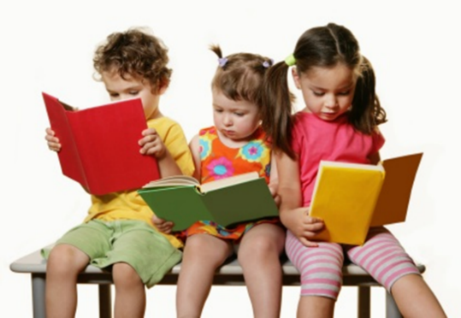

‘Quality not quantity’

Assessment
The EYFS states that:
Assessment plays an important part in helping parents, carers and practitioners to recognise children’s progress, understand their needs, and to plan activities and support. Ongoing assessment (also known as formative assessment) is an integral part of the learning and development process.

It involves practitioners observing children to:
- understand their level of achievement,
- interests
- learning styles
- shape learning experiences for each child reflecting those observations

In their interactions with children, practitioners should respond to their own day-to-day observations about children’s progress and observations that parents and carers share.

Assessment should not:
- entail prolonged breaks from interaction with children
- require excessive paperwork

Paperwork should be limited to that which is absolutely necessary to promote children’s successful learning and development. Parents and/or carers should be kept up-to-date with their child’s progress and development. Practitioners should address any learning and development needs in partnership with parents and/or carers, and any relevant professionals.

Different forms of assessment

Initial Assessment | - First assessment  - Done with parents/carers  - Home visits  - Starting points  - Baseline
Formative Assessment | - Ongoing/day to day  - Knowing and understanding where the child currently is to plan for next steps e.g. using development matters
Summative Assessment | - Statutory assessments  - Progress check at 2  - Early Years Foundation Stage Profile (at the end of the Reception year)  - Data recording at key points in the year

Making assessments of young children is not an exact science. Assessments should, on the whole be based on the professional judgement of the adults who know the child well, using a ‘best fit’ approach. These professional judgements use on-going observational assessment of the child as he/she engages with the environment and interacts in their play and planned activities. It will take account of information from the parents/carers about the child’s interests in the home.
To track and support the development of the whole child it is important that practitioners identify children’s level of development on entry and progress made throughout the year across all 7 areas of learning (broken down into 17 strands) within the EYFS curriculum and the Characteristics of Effective Learning.
The Early Years Inspection Handbook September 2019 states:

The provider must demonstrate how they will:
identify children’s starting points and ensure that children make progress in their learning through effective planning, observation and assessment, if appropriate

Inspectors will talk to practitioners about their assessment of what children know and can do and how they are building on it.

Practitioners and leaders use assessment well to check what children know and can do to inform teaching. This includes planning suitably challenging activities and responding to specific needs. Leaders understand the limitations of assessment and avoid unnecessary burdens for staff or children.
(‘good’ Grade descriptors for the quality of education under implementation)
And
Leaders focus on improving practitioners’ knowledge of the areas of learning and understanding of how children learn to enhance the teaching of the curriculum and appropriate use of assessment. The practice and subject knowledge of practitioners build and improve over time. Leaders have effective systems in place for the supervision and support of staff.
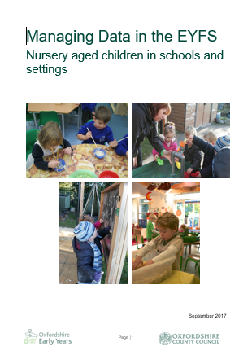
Grade descriptors for leadership and management

Further Information
OCC booklet ‘Managing data in the EYFS’ including how to analyse assessments so that actions are planned in response to trends identified for individuals and groups of children.

Information on two year old reviews can be found here
https://www.oxfordshire.gov.uk/business/information-providers/childrens-services-providers/support-early-years-providers/2-year-old-reviews

Tracking and analysing assessments is important and can be helped by using the OCC Early Years Tracking Tool (EYTT).
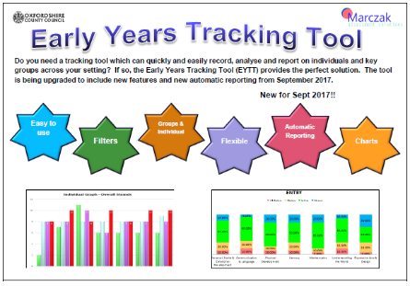

EYFS Profile statutory Assessment at the end of Reception
https://www.gov.uk/government/publications/early-years- foundation-stage-profile-handbook

Planning
The EYFS states:
Practitioners must consider the individual needs, interests, and stage of development of each child in their care, and must use this information to plan a challenging and enjoyable experience for each child in all of the areas of learning and development.

In planning and guiding children’s activities, practitioners must reflect on the different ways that children learn and reflect these in their practice. Three characteristics of effective teaching and learning are:

• playing and exploring - children investigate and experience things, and ‘have a go’
• active learning - children concentrate and keep on trying if they encounter difficulties, and enjoy achievements
• creating and thinking critically - children have and develop their own ideas, make links between ideas, and develop strategies for doing things
Think about how your environment both inside and outside supports the characteristics of effective learning.

Think about the Characteristics of Effective Learning as the ‘how’ children learn rather than ‘what’ they learn (the 7 areas of Learning).

Each area of learning and development must be implemented through planned, purposeful play and through a mix of adult-led and child-initiated activity.
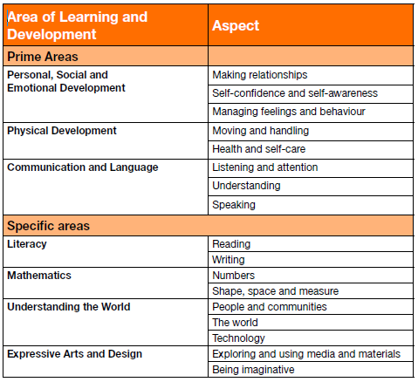
The areas of learning are interlinked and interwoven with the Characteristics of Effective Learning.

There is no one way for planning to be recorded. Planning should be as unique to each school or setting as the children and staff within it. Written plans are a useful way of recording significant information to share with others, documenting the teaching and learning taking place. They provide a basis for mapping out future experiences, activities and achievements, as well as a record of children's previous experiences, interests and progress.

However, a written plan is not an end in itself – it is the planning process that is important.

Successful planning will include a range of different styles and formats but should always relate to the needs of the individuals and groups of children within your current class/group and as a result should be purposeful, flexible and responsive.

Identifying and recording next steps
'Next Steps' is the place to write how the adult needs to respond to the child, outlining the adult's role in supporting the child's future learning. This might be captured on an observation and then transferred to the planning sheet.
Next Steps might be to:
- develop an aspect of child development
- extend an interest
- embed previous learning
- develop a particular Area of Learning e.g. PSED
- teach a new skill
You need to consider:
- what resources to provide
- how you will move the learning forward
- how you will recognise and support ‘how’ a child learns
- the support you need to provide (scaffolding the learning)
- how you will enrich, extend and challenge
- that sometimes children need more of the same or to go back and revisit previous learning
Some useful phrases when writing 'next steps':

Celebrate... Continue to value... Continue to support … Acknowledge … Introduce … Create … Revisit… Repeat…. Follow interest … Provide challenge... Entice...... Respond to…
Watch … Build on… Focus on… Develop skills in ... Note how….
Provoke thinking (open ended questions)

Observation Templates

Short Observation with Areas of Learning and Characteristics of Effective learning
Name of Child: |  |  |  | Observed by:
Date:  Time: | Context (e.g. where is it taking place, child alone or in a group)
Observation:

Areas of Learning observed
PSED  MR SCSA MFB | PD  MH HSC |  | CL  LA U S |  | M  N SSM | UW  PC W T | EAD  EEM BI
Characteristics of Effective Learning Observed
Playing & Exploring  Engagement |  | Active Learning  Motivation |  |  |  | Creating and thinking critically  Thinking
Further opportunities and possibilities/next steps:

Name of Child: |  |  |  | Observed by:
Date:  Time: | Context (e.g. where is it taking place, child alone or in a group)
Observation:

Areas of Learning observed
PSED  MR SCSA MFB | PD  MH HSC |  | CL  LA U S |  | M  N SSM | UW  PC W T | EAD  EEM BI
Characteristics of Effective Learning Observed
Playing & Exploring  Engagement |  | Active Learning  Motivation |  |  |  | Creating and thinking critically  Thinking
Further opportunities and possibilities/next steps:

Long Observation 1
Long Observation 1
Name of child: |  |  |  |  |  |  | Date: |  |  |  | Time:
Activity: |  |  |  |  | In/out |  | CI |  |  | AI |  |  | AD
Areas of Learning and Development
Prime areas |  |  |  | Specific areas
PSED | P | CL |  | L |  | M |  |  | UW |  |  | EAD
Characteristics of Effective Learning
PLAYING AND EXPLORING  (engagement) |  |  | ACTIVE LEARNING  (motivation) |  |  |  |  | CREATING AND THINKING CRITICALLY  (thinking)
Finding out and exploring |  |  | Being involved and concentrating |  |  |  |  | Having their own ideas
Playing with what they know |  |  | Keeping trying |  |  |  |  | Making links
Being willing to ‘have a go’ |  |  | Enjoying achieving what they set out to do |  |  |  |  | Choosing ways to do things
NEXT STEPS FOR LEARNING?

Long Observation 2
Long Observation 2
Child: Date: Time:
Observation:
Characteristics of Effective Learning | Areas of Learning and Development
Playing and exploring – engagement  - Finding out & exploring  - Playing with what they know  - Being willing to ‘have a go  Active learning – motivation  - Being involved and concentrating  - Keeping on trying  - Enjoying achieving what they set out to do  Creating and thinking critically – thinking  - Having their own ideas  - Making links  - Choosing ways to do things | Prime Areas | Specific Areas
 | Personal Social and Emotional Development  - Making relationships  - Self -confidence and self-awareness  - Managing feelings and behaviour  Physical Development –  - Moving & handling  - Health & self-care  Communication and Language  - Listening & attention  - Understanding  - Speaking | Literacy  - Reading  - Writing  Mathematics  - Numbers  - Shape, space and measure  Understanding the World  - People & communities  - The world  - Technology  Expressive Arts and Design  - Exploring and using media and materials  - Being imaginative
Observation Continued:

Next Steps:

Long Observation 3

Long Observation 3
Name of child
Date: Time: |  |  |  |  |  | Observation completed by:
Child Initiated Activity: |  |  |  |  |  | Adult Led Activity:
Solitary Play |  | Parallel Play |  |  |  | Small group Play |  | Large Group Play
PSED | C&L |  | PD |  | L |  | M |  | U the W | EA&D
Context: (where is the child? Who else is present?)
What is happening? (What is the child saying and/or doing?)

Is the child:
- Showing curiosity?  - Using their senses?  - Engaging in open ended activity?  - Showing particular interests?  - Pretending objects are things?  - Representing experiences in play?  - Taking on a role in play?  - Acting out experiences with other people?  - Initiating activities?  - Seeking challenges?  - Showing a ‘can do’ attitude?  - Taking a risk? Engaging in new experiences and learning by trial and error? |  |  |  | - Maintaining focus on their activity for a period of time?  - Showing high levels of energy/fascination?  - Not easily distracted?  - Paying attention to detail?  - Persisting with activity when challenges occur?  - Showing belief that effort or a different approach will pay off?  - Bouncing back after difficulties?  - Showing satisfaction in meeting own goals?  - Proud of accomplishments regardless of end result?  - Enjoying meeting challenges for own sake? |  |  |  |  | - Thinking of ideas?  - Finding ways to solve problems?  - Finding new ways to do things?  - Making links and noticing patterns in their experience?  - Making predictions?  - Testing their ideas?  - Developing ideas of grouping, sequencing, cause and effect?  - Checking how well their activities are going?  - Changing strategy as needed?  - Reviewing how well the approach worked?
NEXT STEPS:

Long Observation 4
Long Observation 4
Child’s name: | Age (in months): |  | Observer:
SEN EAL PP | Date: Time:
Context (where, how) | Adult involvement: yes no
OBSERVATION: What did you find out about the child’s learning across any of the 3 prime areas and 4 specific areas of learning? What was significant for the child?
GENERAL |  | PSED (MR; SC&SA; MF&B)
 |  | PD (M&H; H&SC)
 |  | CL(L&A; U; S)
 |  | L (R; W)
 |  | M (N; SSM)
 |  | UW (P&C; TW; T)
 |  | EAD (E&UM&M; BI)

General (continued) | Characteristics of Effective Learning
 | Playing and Exploring (Engagement)
 | Active Learning (Motivation)
 | Creating and Thinking Critically (Thinking)
Child’s Response (verbal and / or non-verbal (try to make time to inform the child about the observation. Consider showing the child a photograph of his / her play that was observed and capture his / her response).

Significant progress and achievements identified during the observation. | Learning priorities identified – What next?

Narrative Observation Form
Child’s Name: |  |  |  | Observer’s Name:
Date: |  | Time: |  | Context:
Observation Notes:

Characteristics of effective learning
Playing and Exploring -engagement |  |  | Active Learning -motivation |  |  | Creating and Thinking Critically - thinking
Finding out & exploring:-  - Showing curiosity about objects, events and people  - Using senses to explore the world around them  - Engaging in open ended activity  - Showing particular interests |  |  | Being involved & concentrating:-  - Maintaining focus on their activity for a period of time  - Showing high levels of energy and fascination  - Not easily distracted  - Paying attention to details |  |  | Having their own ideas:-  - Thinking of ideas  - Finding ways to solve problems  - Finding new ways to do things
Playing with what they know:-  - Pretending objects are things from their experiences  - Representing their experiences in play  - Taking on a role in their play  - Acting out experiences with other people |  |  | Keeping trying:-  - Persisting with activity when challenges occur  - Showing a belief that more effort or a different approach will pay off  - Bouncing back after difficulties |  |  | Making links:-  - Making links and noticing patterns in their experiences  - Making predictions  - Testing their ideas  - Developing ideas of grouping, sequencing, cause and effect
Being willing to “have a go”:-  - Initiating activities  - Seeking challenge  - Showing a ‘can do’ attitude  - Taking a risk, engaging in new experiences, learning by trial and error |  |  | Enjoying & achieving what they do:-  - Showing satisfaction in meeting their own goals  - Being proud of how they accomplished something – not just the end result  - Enjoying meeting challenges for their own sake rather than external rewards or praise |  |  | Choosing ways to do things:-  - Planning, making decisions about how to approach a task, solve a problem and reach a goal  - Checking how well their activities are going  - Changing strategy as needed  - Reviewing how well the approach worked
Schemas observed in play |  |  |  |  | Involvement scales
Positioning | Transporter |  | Transformer |  | 1.Extremely Low | 2. Low | 3. Moderate
Very precise about where things should be and enjoy lining up toys | Carrying objects from one place to another in bags, buckets etc |  | Mix colours, textures, enjoy malleable material |  | No concentration, absent, passive attitude, no signs of exploring things | Some degree of activity, limited concentration, fiddles, easily distracted | Busy all the time but no real concentration, activities are short lived, no dedication to an activity, not child’s full potential
Rotation | Connection |  | Enclosure |  | 4. High | 5. Very High
Fascinated by spinning wheels, wheels on cars, rotating items, enjoy spinning or being spun round | Enjoy spending time joining things together, using tape to join or put together obstacle courses |  | Fill empty containers, sit in tunnels, build dens or cages |  | Engaged without interruption, real concentration most of the time, brief moments of distortion, child feels challenged and motivated | Continuously engaged and absorbed, focussed without interruption, strongly appealed by activity. Is alert, shows precision, intense, engrossed in activity, child’s capabilities shine.
Enveloping | Trajectory
Covering up themselves or dolls/toys in blankets, painting using one colour | Play with running water, climb up and jump off equipment, throw toys and balls
Next steps:

Parent’s input:

Long observation timetable
Term: Autumn 1
 | Staff Member 1 | Staff Member 2 | Staff Member 3
Week 1 | Lottie, Harry, Ben | Josh, Molly, Gilbert
Week 2 | Lucy, Andy, Ahmed | Sarah, Ellie
Week 3 | Marcus, Alfie, Martha | Carl, James
Week 4 | Lily-Mae, Jess, Charlie | Laura, Hannah
Week 5 | Tyrone, Esme, William | Finlay, George
Week 6 | Ruby, Ollie | Lottie, Dan
N.B – This timetable is for a class of 30 children. A long observation would on average be between 5 – 10 mins. With three children to observe in this way over the week that is only a maximum of 30 mins per week.

Characteristics of effective learning observation
Name of child: Date: Time:
Activity:
Details/Context: (could include a photo)
Characteristics of effective learning (how children learn) shown in observation:
Playing and exploring | Active learning | Creating/thinking critically
Finding out and exploring  Showing curiosity about objects, events and people.  Using senses to explore the world around them.  Showing particular interests. | Being involved and concentrating  Maintaining focus on their activity for extended periods of time.  Showing high levels of energy, fascination.  Not easily distracted.  Paying attention to details | Have their own ideas  Thinking of ideas.  Finding ways to solve problems.  Finding new ways to do things
Playing with what they know  Pretending objects are things from their experience.  Representing their experiences in play.  Acting out experiences with other people. | Keeping on trying  Persisting with activity when challenges occur.  Showing a belief that more effort or a different approach will pay off.  Bouncing back after difficulties. | Making links  Making links and noticing patterns in their experience.  Making predictions.  Testing their ideas.  Developing ideas of grouping, sequences, cause and effect.
Being willing to have a go  Initiating activities.  Seeking challenge.  Showing a “can do” attitude.  Taking a risk, engaging in new experiences, and learning by trial and error. | Enjoying achieving what they set out to do  Showing satisfaction in meeting their goals.  Being proud of how they accomplished something-not just the end result.  Enjoying meeting challenges for their own sake rather than external rewards or praise. | Choosing ways to do things  Planning, making decisions about how to approach a new task, solve a problem and reach a goal.  Checking how well their activities are going.  Changing strategy as needed.  Reviewing how well the approach worked
AREA OF LEARNING AND DEVELOPMENT: PSED CL PD L M UW EAD
AGE BAND: Birth – 11 months 8 – 20 months 16 – 26 months 22 – 36 months 30 – 50 months 40 – 60+ months
C B A
Next steps: What will you do to celebrate/extend/provide opportunities to repeat or practice/change something/scaffold/consolidate?

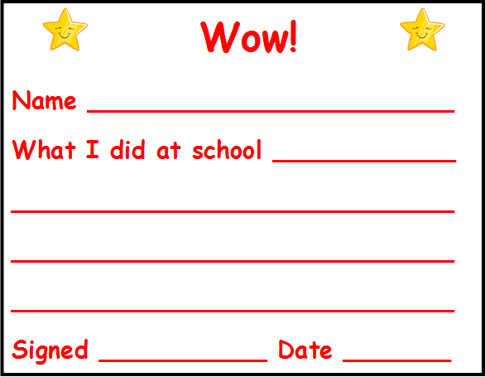

Wow!
Name ________________________
What I did at home ____________
_____________________________
_____________________________
_____________________________
Signed ___________ Date _______

Assessment Templates
All about me! My name is ______________ Today’s date is _______
Please fill in the following information to help us learn more about your child.

These people are Special to me e.g. my family/extended family/friends My interests are…

Draw a picture of yourself

Things I don’t like are…

When I am sad I need….

My favourite toys are….

I would like to know more about….

Data response following summative data snap-shot
Area of Learning – Cohort Size -
Group break down (including vulnerable groups)  (Delete as appropriate) | % / No. of children working above  % / No of children working in line  % / No of children working below  % / No of children working significantly below | Names of children in group | Actions | Impact
Girls

Boys

FSM/PP/EYPP

Non FSM/PP/EYPP

SEN

Non SEN

EAL

Non EAL

Forces

Non Forces

LAC

Non LAC

Tracking the impact of provision on the progress made by a child eligible for Early Years Pupil Premium funding (Nursery)

Pupil Name: Age on entry (in months):
Entry Assessment date:
Well-being and Involvement:
Well-being | Low | Medium | High
Involvement | Low | Medium | High

Characteristics of Effective Learning (narrative):
Engagement | Motivation | Creating and Thinking Critically

Areas of Learning
C&L |  |  | PD |  | PSED |  |  | Lit |  | Maths |  | UtW |  |  | EAD
L&A | U | S | MH | H&SC | SCSA | MR | MF&B | R | W | N | SSM | PC | TW | T | EMM | BI

Are they working within their Developmental Age/Stage Band (Development Matters)? Yes No

Identified areas of need:

Identified resources needed using EYPP funding:

How did your provision respond to this child’s needs? (Environment, adult roles, teaching and learning, interventions)

Assessment date:
Well-being and Involvement:
Well-being | Low | Medium | High
Involvement | Low | Medium | High

Characteristics of Effective Learning (narrative):
Engagement | Motivation | Creating and Thinking Critically

Areas of Learning:
C&L |  |  | PD |  | PSED |  |  | Lit |  | Maths |  | UtW |  |  | EAD
L&A | U | S | MH | H&SC | SCSA | MR | MF&B | R | W | N | SSM | PC | TW | T | EMM | BI

Are they working within their Developmental Age/Stage Band (Development Matters)? Yes No

Review of:
Identified areas of need:

Identified resources needed using PP funding:

How did your provision respond to this child’s needs? (Environment, adult roles, teaching and learning, interventions)

What impact has your provision had?

Tracking the impact of provision on progress made by a child eligible for Pupil Premium funding (Reception)

Pupil Name: Age on entry (in months):
Entry Assessment date:
Well-being and Involvement:
Well-being | Low | Medium | High
Involvement | Low | Medium | High

Characteristics of Effective Learning (narrative):
Engagement | Motivation | Creating and Thinking Critically

Areas of Learning
C&L |  |  | PD |  | PSED |  |  | Lit |  | Maths |  | UtW |  |  | EAD
L&A | U | S | MH | H&SC | SCSA | MR | MF&B | R | W | N | SSM | PC | TW | T | EMM | BI

On track to get a good level of development? Yes No

Identified areas of need:

Identified resources needed using PP funding:

How did your provision respond to this child’s needs? (Environment, adult roles, teaching and learning, interventions)

Assessment date:
Well-being and Involvement:
Well-being | Low | Medium | High
Involvement | Low | Medium | High

Characteristics of Effective Learning (narrative):
Engagement | Motivation | Creating and Thinking Critically

Areas of Learning:
C&L |  |  | PD |  | PSED |  |  | Lit |  | Maths |  | UtW |  |  | EAD
L&A | U | S | MH | H&SC | SCSA | MR | MF&B | R | W | N | SSM | PC | TW | T | EMM | BI

On track to get a good level of development? Yes No

Review of:
Identified areas of need:

Identified resources needed using PP funding:

How did your provision respond to this child’s needs? (Environment, adult roles, teaching and learning, interventions)

What impact has your provision had?

Tracking the impact of provision on progress made by a child not on track to achieve a GLD (Reception)

Pupil Name: Age on entry (in months):
Entry Assessment date:
Well-being and Involvement:
Well-being | Low | Medium | High
Involvement | Low | Medium | High

Characteristics of Effective Learning (narrative):
Engagement | Motivation | Creating and Thinking Critically

Areas of Learning
C&L |  |  | PD |  | PSED |  |  | Lit |  | Maths |  | UtW |  |  | EAD
L&A | U | S | MH | H&SC | SCSA | MR | MF&B | R | W | N | SSM | PC | TW | T | EMM | BI

On track to get a good level of development? Yes No

Identified areas of need:

Identified resources needed:

How did your provision respond to this child’s needs? (Environment, adult roles, teaching and learning, interventions)

Assessment date:
Well-being and Involvement:
Well-being | Low | Medium | High
Involvement | Low | Medium | High

Characteristics of Effective Learning (narrative):
Engagement | Motivation | Creating and Thinking Critically

Areas of Learning:
C&L |  |  | PD |  | PSED |  |  | Lit |  | Maths |  | UtW |  |  | EAD
L&A | U | S | MH | H&SC | SCSA | MR | MF&B | R | W | N | SSM | PC | TW | T | EMM | BI

On track to get a good level of development? Yes No

Review of:
Identified areas of need:

Identified resources needed:

How did your provision respond to this child’s needs? (Environment, adult roles, teaching and learning, interventions)

What impact has your provision had?

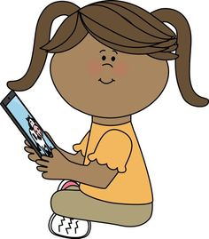
ICT AT HOME

Name of child:……………………………………

Dear parents and carers.

As part of our assessment at the end of the Reception year, we will report on children’s abilities in Technology. What we are finding is that technology at School often lags behind, or is different to, what children do at home. So that we can better understand their skills and interests and plan for future activities, it would be helpful if you could tell us about how your child uses technology at home. Please could you take a few minutes to complete this short questionnaire and return it to school?
- Does your child use any of this technology?

Please √ or x | On own | With help | Doesn’t use | Details
Laptop or desktop computer
Internet websites
(i.e. cbeebies),or tablet apps
Mobile/Smart phone
Interactive TV / smart speaker
DVD/CD player
Game console
Programmable toy (e.g. a remote control car)

Other: please list ………………………………………………………………………

- Can your child use Technology to support an identified need – eg Skyping/facetime a relative, finding and using a favourite App/programme, setting the timer on the microwave, playing music on an i-pod to dance to taking a photo on a phone, ask Alexa?

Yes, on own | With help | Doesn’t choose to/ no

Please give an example……………………………………………………………………………………………............

………………………………………………………………………………………………………………

Many thanks.

Planning Templates

Enhanced Provision planning
Class ……………………. Weekly Plan Date:
Enhanced Provision Planning
 | Monday | Tuesday | Wednesday | Thursday | Friday
Fine Motor

Writing

Malleable/Tactile

ICT

Listening

Reading

Small world

Role play

Creative/Art

Sand

Water

General Enhancements
Mathematics

Construction

Gross motor

Exploration & Investigation

Mud kitchen

Forest school

Activities planned in response to children’s interest or next steps have child’s initials on.

Enhanced Provision planning
 | Monday | Tuesday | Wednesday | Thursday | Friday
PSED

Communication & Language

Physical
Development

Literacy

Maths

Understanding the world

Expressive
Arts & Design

Activities planned in response to children’s interest or next steps have child’s initials on.

Focused activity/Experience plan
Date: |  | Activity/Experience:
PSED PD CL L M UW EAD
MR MFB SCSA | MH HSC |  | LA U S | R W | N SSM | PC W T | EMM BI
What do I want the children to learn: (Learning intention/objective) |  |  |  | Key Vocabulary/Questions:
How are we going to do this?

What will I need? (Resources)

Which children will be involved?

How will it be differentiated?

How did it go? (Evaluation)

What next? (Children’s developmental next steps, environment, resources)

Weekly Planning sheet W/B…………
 | The Prime Areas of learning | Intended Learning (differentiation of expected outcomes) | Adult Focused Activities | Adult Initiated Activities | Resources for Child Initiated Learning | Key Questions and Language | Evaluation and Assessment
 |  | Personal, Social and Emotional Development
 |  | Physical Development
 |  | Communication and Language
The Specific Areas of Learning |  | Intended Learning (differentiation of expected outcomes) | Adult Focused Activities | Adult Initiated Activities | Resources for Child Initiated Learning | Key Questions and Language | Evaluation and Assessment
 |  | Literacy
 |  | Mathematics
 |  | Understanding the World
 |  | Expressive Arts and Design

