Managing Data in the EYFS
Nursery aged children in schools and settings
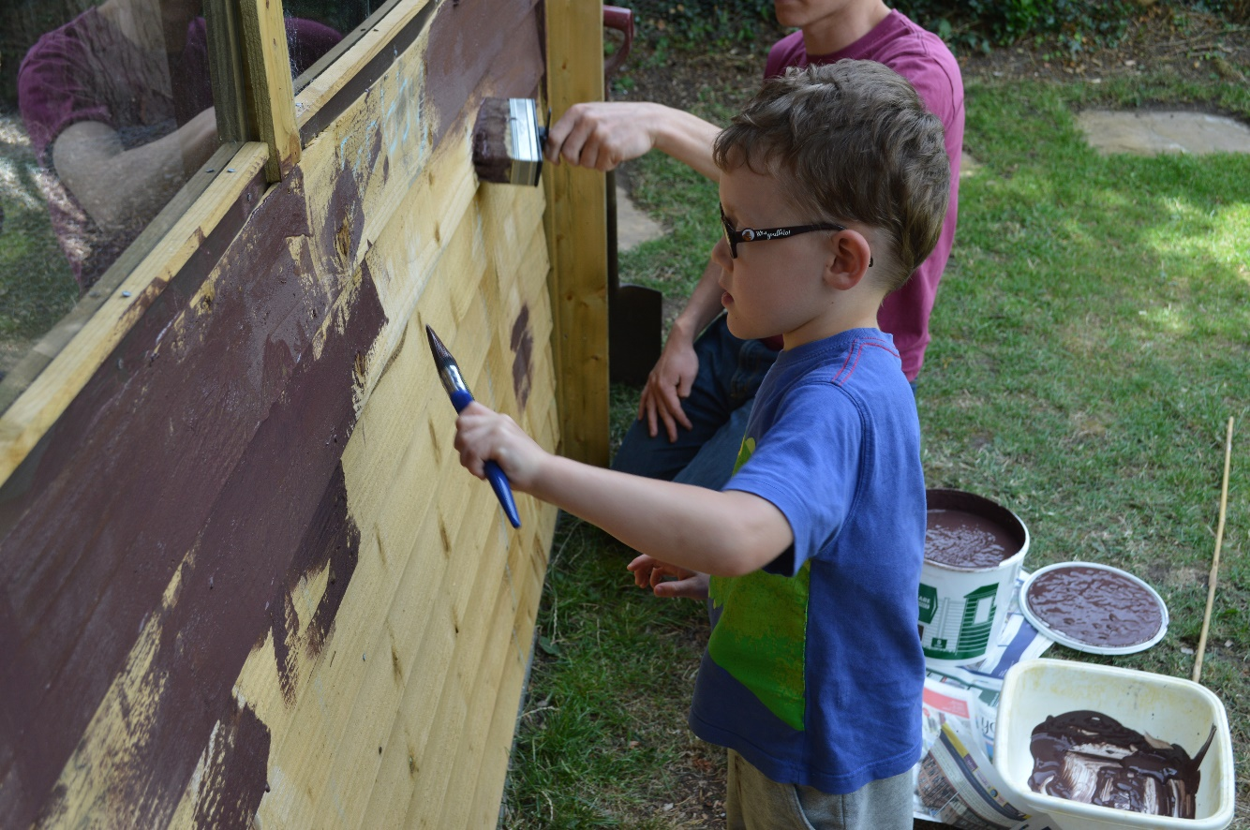
September 2019

The Early Years Foundation Stage (EYFS)
The Early Years Statutory Framework (updated April 2017) is mandatory for all early years providers - maintained schools, non-maintained schools, independent schools, and all providers on the Early Years Register. The EYFS sets the standards that all Early Years providers must meet to ensure that children learn and develop well and are kept healthy and safe. It promotes teaching and learning to ensure children’s ‘school readiness’ and gives children the broad range of knowledge and skills that provide the right foundation for good future progress through school and life.
There are seven areas of learning and development that must shape educational programmes in early years settings. All areas of learning and development are important and inter-connected. Three areas are particularly crucial for igniting children’s curiosity and enthusiasm for learning, and for building their capacity to learn, form relationships and thrive. These three areas, the prime areas, are:
- communication and language
- physical development
- personal, social and emotional development
Providers must also support children in four specific areas, through which the three prime areas are strengthened and applied. The specific areas are:
- literacy
- mathematics
- understanding the world
- expressive arts and design
In planning and guiding children’s activities, practitioners must consider the different ways that children learn and reflect these in their practice. Three characteristics of effective teaching and learning are:
- playing and exploring - children investigate and experience things, and ‘have a go’
- active learning - children concentrate and keep on trying if they encounter difficulties, and enjoy achievements
- creating and thinking critically - children have and develop their own ideas, make links between ideas, and develop strategies for doing things

Development Matters
Development Matters (March 2012) is non-statutory guidance material that supports practitioners in implementing the statutory requirements of the EYFS. It states that:
“Children develop at their own rates, and in their own ways. The development statements and their order should not be taken as necessary steps for individual children. They should not be used as checklists. The age/stage bands overlap because these are not fixed age boundaries but suggest a typical range of development.”
These statements can be used throughout the EYFS as a guide to make ‘best fit’ judgements about whether a child is showing typical development for their age, may be at risk of delay or is ahead for their age.

Individual observations may be linked to Development Matters bands as part of formative assessment. As well as the day to day observations and assessments you make as you get to know the children, it is recommended that judgements across all areas of learning should be made on entry and at several points throughout the year. This is to enable you to consider the overall progress a child is making, and whether progress is generally in line with what is typical for a child of that age. Learning and development is compared with the most appropriate band(s) of descriptors and the band which most closely describes the child’s developmental stage is identified.
Using an ‘A’, ‘B’ or ‘C’ model, a level can be awarded within each developmental age/stage band using a ‘best fit’ approach.
- if the child is working just within the band record as a ‘C’ (emerging):
- if the child is working comfortably within the age band record as a ‘B’ (developing)
- If the child is very proficient within the band record as an ‘A’ (secure)

Because this is a ‘best fit’ judgement, it does not involve recording evidence for or highlighting every single ‘Development Matters’ statement. Rather the child’s key person and the class teacher/ EY practitioner, in discussion with all others involved with the child, will make professional judgments about which level of development best describes the child at that moment on their developmental journey. These professional judgements will be based upon on-going observational assessment of the child as he/she engages with the environment and interacts in their play with other children and adults. It will take account of information from the parents/carers about the child’s interests and activities in the home.
NB Please be aware that some digital tools, commonly used in EY settings e.g. Tapestry, will generate judgements solely based on the observations that have been collected. These may not be a best fit judgement based on practitioner’s professional knowledge of the child and should be amended.
To track and support the development of the whole child, it is important that practitioners identify children’s level of development on entry and progress made throughout the year across all 7 areas of learning (broken down into 17 strands) within the EYFS curriculum and the Characteristics of Effective Learning.

Initial Assessment on entry to Reception
Practitioners in Nursery classes and in settings with children of nursery age will need to know what assessments will be made in Reception and what their role is in sharing information with colleagues in Reception classes.

National expectations on entry
Ofsted no longer refers to ‘on entry’ benchmarks of 30-50 months for Nursery children. A child entering Nursery at the age of three working proficiently within 22-36 months could be considered as ‘age typical’, depending upon their date of birth. For example, individual children may be:
- operating at a level below that typical for their age but not significantly so (this may reflect a lack of pre-school experience)
- showing a typical level of development for their age
- operating at a level above that typical for their age (indicating the potential to exceed the early learning goals by the end of reception).
Others may be operating at a level significantly below that which is typical for their age. Such children may be at risk of delay or may have a particular disability or special educational need that has already been identified.
The Early Years Inspection Handbook that came into effect from 1 September 2019 states that
‘Inspectors…should consider
- the progress children make in their learning and development relative to their starting points, and their readiness for the next stage of their education.’ (p. 29)

National expectations on exit
There are no set National expectations for children’s attainment at the end of the nursery year. Summative attainment is measured at the end of EYFS (the end of the child’s Reception year) using the Early Years Foundation Stage Profile. This will remain a statutory requirement for 2020.
For children in their nursery year the expectations are that they will be at or above the level of development for their age on exit. This will differ for individual children depending on their term of birth. The suggested age-related expectation for entry into Reception, and therefore at the end of Nursery, is 30-60a or 40-60c, (based on their birth date in months.)

Assessing Progress
The Early years inspection handbook 2019 states that

The provider must demonstrate how they will:
- identify children’s starting points and ensure that children make progress in their learning through effective planning, observation and assessment, if appropriate. (p.6)

and in settings judged to be ‘Good’ …
- Practitioners and leaders use assessment well to check what children know and can do to inform teaching. This includes planning suitably challenging activities and responding to specific needs. Leaders understand the limitations of assessment and avoid unnecessary burdens for staff or children. (p.34)
For example, where children progress steadily against what is a typical level of development for their age, they can be said to have made typical progress. Children are working within age/stage related expectations but who started at a lower level of development than is typical for their age might be said to be making more than typical or rapid progress. However, a child starting school at a higher level of development, who is working at age/stage related expectations but not beyond this level on exit, is unlikely to have made enough progress.
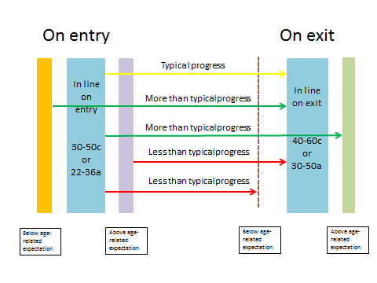

E.g. A child who enters Nursery, at a level ‘typical’ for their age e.g. just beginning to work within the 30-50 months age banding / working proficiently within the 22-36 months age banding (depending on their age) and leaves being proficient within 30-50 months age banding or just beginning to work within the 40-60+ months age band, will have made ‘typical progress’.

Tracking tools
Early Year Tracking Tool (EYTT) - The tool can be used to track attainment and progress from Birth to 5 and can be configured to suit individual setting requirements. The tool has received many positive comments from Ofsted inspectors, advisors and settings alike.
N.B. other commercial tools are available such as Classroom Monitor, Insight, and ITrack.

Tracking sheets to support more detailed assessment of level of development and progress made are available from the Early Years Toolkit (now available as part of the Early Years Support Package eg. Nursery class (Nursery age children) tracker by term of birth
In addition, a range of electronic tools are available for practitioners working in the EYFS to help record observations, photographs and videos, creating Learning Journals/ Logs such as 2Simple’s ‘2 Build a Profile’, ‘Tapestry,’ an Early Years Online Learning Journal from The Foundation Stage Forum, ‘Fingertips Online.’ Costs vary. They allow practitioners to involve parents/carers in contributing to the child’s journal electronically.

Identifying and reporting on specific groups of children
SEN, EAL, Early Years Pupil Premium, significant ethnic groups, more able
Ofsted states that ‘Good’ practitioners ‘use additional funding, including the early years pupil premium where applicable, and measure its impact on disadvantaged children’s outcomes.’
Early Years Pupil Premium Funding – The linked webpages give information about eligibility for Early Years Pupil Premium and how providers could use this funding to improve outcomes for children.

Special Educational Needs and Disabilities
Children within the Early Years Foundation Stage with SEND are entitled to high-quality early years provision based on the EYFS framework, its principles and commitments. They should be supported in pursuing unique paths in their learning and development toward the early learning goals. Assessment of their progress should take account of the developmental bands described in Development Matters / Early Years Outcomes, recognising that progress is not linear.
(Further information on accessing supportive funding is available here.)

Early Support Developmental Journals
Early Years Developmental Journals are available for young children with very specific needs e.g. Down’s syndrome/autism etc. The Early Years Developmental Journal has been produced to help families find out more about early development and to track change and progress over time. It helps everyone involved with a child to share what they know and discuss how best to work together to support development and learning.

Children who speak English as an additional language
EAL - The Department of Education definition
‘A pupil’s first language is defined as any language other than English that a child was exposed to during early development and continues to be exposed to in the home or community. If a child was exposed to more than one language (which may include English) during early development, a language other than English should be recorded, irrespective of the child’s proficiency in English.’
Learning to speak English as an additional language is not a special educational need. Practitioners should assess the development of children who speak English as an additional language in their home language as well as in English, where possible. While the children’s skills in communication, language and literacy must be assessed in relation to their competency in English, the remaining areas of learning may be assessed in any language.
The booklet Identifying Children who are Learning English as an Additional Language and who may also have Learning Difficulties and/or Disabilities provides templates for tracking children’s language development over time.
Responding to data analysis
‘When used well, data can have a profound and positive impact.’
(Eliminating unnecessary workload associated with data management - Report of the Independent Teacher Workload Review Group March 2016)
‘Assessment and progress tracking were believed to be only valuable if used effectively to support learning and development, identify children requiring additional support, and feed into curriculum planning. Features of good practice felt to support this included:
- Regular communication between staff to raise awareness of issues identified through assessment;
- High staff /child ratios that gave staff sufficient time to carry out regular observations and;
- Effective use of digital assessment tools that supported practitioner judgements and facilitated timely analysis of data.’
Study of Early Education and Development: Good Practice in Early Education - Research report (January 2017)

Lead Practitioners/Managers should analyse achievement data each year.
Alistair Bryce-Clegg recommends conducting ‘a Gap and Strength Analysis.’
‘This uses the information that you gain from your summative assessment to show where the greatest areas of need and strength are within your cohort. You would then make sure that they environment and provision that you put in place directly reflects the needs that you have identified.’
Further suggestions for analysis are:
- How many children are working at or beyond their individual developmental age/stage band? What is this as a percentage?
- How many of these children were boys, girls, autumn/spring/summer born, EAL, SEND, Pupil Premium, FSM, GRT, LAC, more able, forces families; consider children’s starting points
- Look at those children who working at or beyond their individual developmental age/stage band. Are there any patterns in attainment? e.g. Are there any correlations between different areas of learning such as Literacy and Communication and Language?
- Do children with high outcomes also have high scores in PSED and demonstrate this through the characteristics of effective learning?
- What aspects of breadth/depth of EYFS provision need further development?
- What are the strengths and key aspects for improvement across the areas of learning and development for this year’s cohort?

Other:
- Are there differences in the data between classes / rooms (if applicable)?
- What does the data tell us about the attainment and needs of individual children e.g. SEND/EAL/Early Years Pupil Premium/more able?
- How are Reception colleagues using the data to inform planning for the start of the next academic year? Do they have copies of ‘Development Matters’?
- What does the data tell us about priorities for your class / setting?
- What does the final data tell you about the quality of your practice and provision? What changes could be made to improve outcomes next year? Add any specific actions in response to data analysis to your Action Plan.

NB The Early Years Inspection Handbook 2019 notes that, in settings judged ‘Good ‘
‘Leaders understand the limitations of assessment and avoid unnecessary burdens for staff or children.’

References
- Alistair Bryce-Clegg https://abcdoes.com/abc-does-a-blog/2014/01/07/promoting-attainment-in-eyfs-gap-analysis/
- Development Matters in the Early Years Foundation Stage (Early Education May 2012)
- Early years inspection handbook (Ofsted, September 2019)
- Eliminating unnecessary workload associated with data management - Report of the Independent Teacher Workload Review Group March 2016
Identifying children who are learning English as an additional language and who may also have learning difficulties and/or disabilities (Oxfordshire County Council January 2009)

