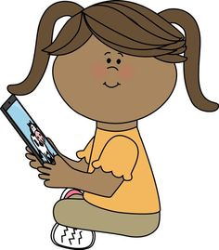
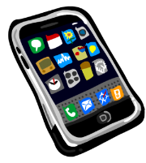
ICT AT HOME

Name of child:……………………………………

Dear parents and carers.

As part of our assessment at the end of the Reception year, we will report on children’s abilities in Technology. What we are finding is that technology at School often lags behind, or is different to, what children do at home. So that we can better understand their skills and interests and plan for future activities, it would be helpful if you could tell us about how your child uses technology at home. Please could you take a few minutes to complete this short questionnaire and return it to school?
- Does your child use any of this technology?

Please √ or x | On own | With help | Doesn’t use | Details
Laptop or desktop computer
Internet websites
(i.e. cbeebies) / tablet apps
Mobile/Smart phone
Interactive TV / smart speaker
DVD / CD player
Game console
Programmable toy (e.g. a remote control car)

Other: please list ………………………………………………………………………

- Can your child use Technology to support an identified need? – eg Skyping/facetime a relative, finding and using a favourite App/programme, setting the timer on the microwave, playing music on a smart device to dance to, taking a photo on a phone, ask Alexa?
Yes, on own | With help | Doesn’t choose to/ no
Please give an example……………………………………………………………………………………………............

………………………………………………………………………………………………………………

Many thanks for your support.

The voice of the Child
This is what I like to do at home with Technology – You can draw or write what you use

