Guidance for developing an action plan
Early Years Foundation Stage

What is an action plan?
- An action plan is a written framework to guide you in improving some aspects of your work over a period of time

What does it include?
- It states some changes you want to make
- It sets out manageable steps to make these changes (actions)
- It shows who will be involved
- It shows what evidence of success is required
- It shows how changes will be monitored
- It shows if actions have been effective (impact)

Who writes the action plan?
- The Coordinator / Manager is responsible for writing down the action plan and recording evidence of success, but all staff – and sometimes parents, children and management committees – should be involved in deciding the actions and putting it into practice

Remember SMARTI
Specific | Measurable | Attainable | Realistic | Time scale | Inclusive

Linking with the MUSTS audit:
The action plan should help you to meet the requirements of the Statutory Framework for the Early Years Foundation Stage (2017). The Oxfordshire Audit of the EYFS (known as the ‘MUSTS’ audit) can be used as a starting point in the cycle of auditing and action planning for improvement in your setting.

Effective action planning
- It may be helpful to start with ‘where are we now’ before creating the action plan – audits can support this and will demonstrate your progress towards improvement
- Issues or developments may originate from ‘Your priorities for improvement’ identified in your Self Evaluation Form (SEF); Ofsted Inspection Actions or Recommendations; Consultant advice; consultation with parents; training attended; professional reading and research; local and national initiatives etc.
- A single issue or development may require several actions
- It can be helpful to group actions under the four Ofsted Inspection outcomes: Leadership and Management; Teaching, Learning and Assessment; Personal Development, Behaviour and Welfare (including safeguarding); Outcomes for Children (see templates in OCC Early Years online Toolkit)
- Specific dates should be allocated to actions to allow for effective monitoring
- All reviews and entries should be dated
- If identified actions have not been successful in addressing the issue or achieving the development, then new actions should be planned
- An effective action plan is a working document and should be constantly reviewed and updated
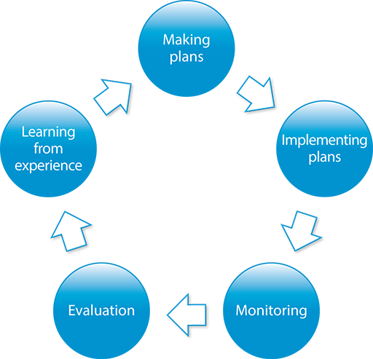

Sample templates
See below for a variety of templates which can be adapted to suit your needs. Further templates are also available in the OCC Early Years online Toolkit which you can also adapt for your own use.

Action plan
What you need to improve | Action | What steps will you take | Who will be responsible for specific steps | What evidence will show success | Date for completion | Who will monitor completion | Evidence of impact on children when actions are complete

Action plan
School / Setting
Date

Action | Who and When? | Review / Evaluate | Impact on Children

Action plan
Action | Timescale | Resource implications | Lead Responsibility / Linked Staff | Monitoring Procedures | Success Criteria | Evaluation/ Impact on Children

Action Plan for _________________________________________
Date:
Objective | Action | When | Who | Evaluation/ impact on children

EYFS Action Plan Setting Name: Date:

Issue/  development | Source  (e.g. from an audit/SEF /Ofsted action/training/EYAT action etc.) | Actions  (e.g. audit; training; document update; data analysis; consultation etc.) | Timescale  (when and by when) | Responsibility  (who) | Resource  Implication  (e.g. budget/ supply/  /training costs/new equipment) | Success Criteria  (how you will know it has been achieved) | Achieved?  Update/evaluation  (include dates)
Impact - what impact has there been (on provision/practice/improvements for children)? Include evidence and dates:

