August 2017

Guidance for Early Years practitioners on supporting children learning English as an Additional Language (EAL).

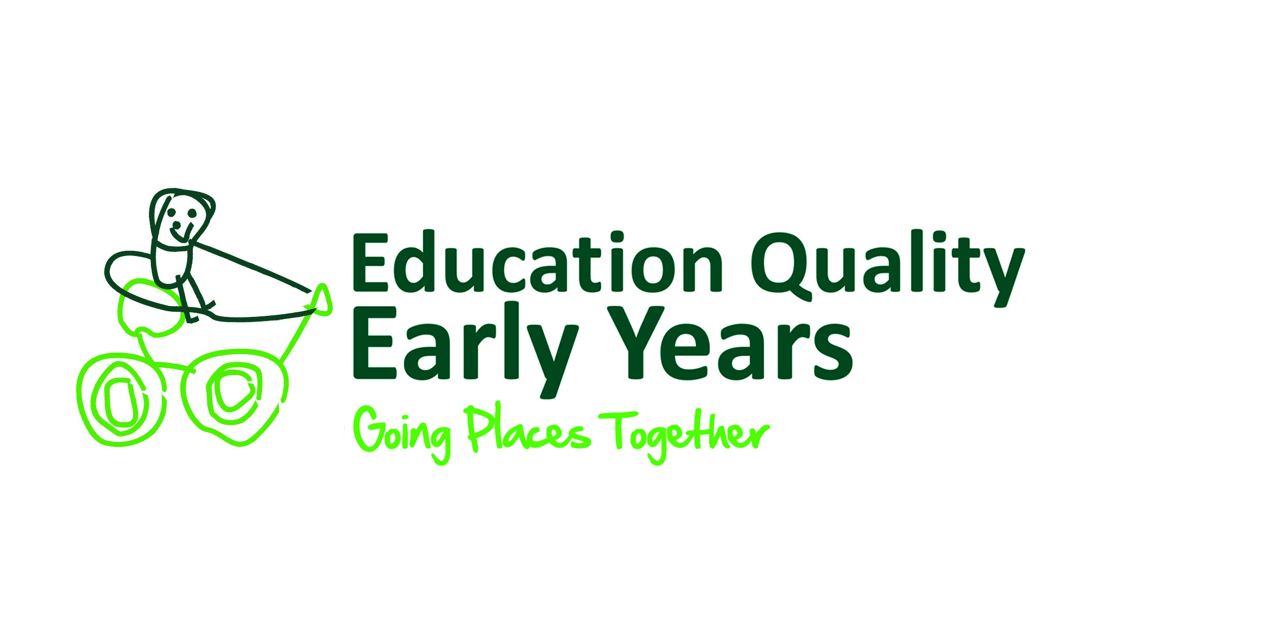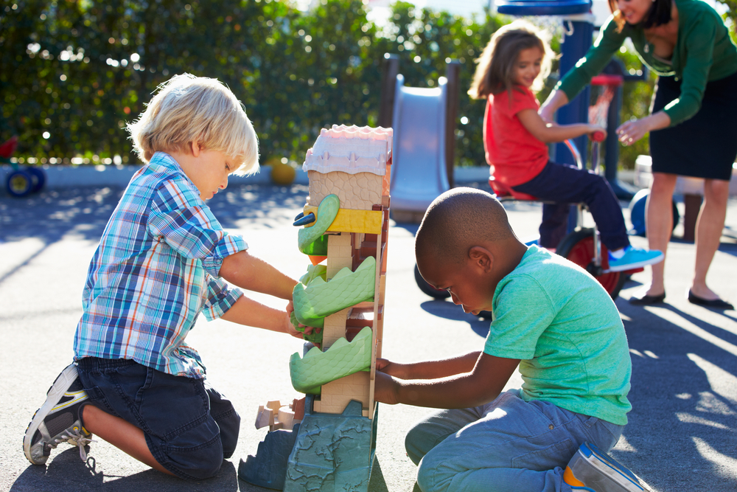

Contents

Introduction 2

How do we know if a child is EAL? 2

Definitions of EAL 2

Principles and Best Practice 3

Practitioners and Learning 4

Statutory requirements in the Early Years 7

The Characteristics of Effective Learning9

UN convention on the Rights of the Child 10

Assessment of education provision 11

Strategies for supporting/developing communication in English13

Appendix 1

Observations of EAL and suggested Practitioner Strategies 14

School EAL proficiency requirements new codes17

How to identify and support EAL learners with Special Educational Needs 18

Appendix 2

Case studies 20

Ofsted inspection quotes and improvement needed quotes 20

Frequently asked questions 21

Books for EAL Learner22

Games for Early Years EAL Learners 23

Useful links/references 24

Introduction

We can do a lot to support children who are learning EAL in our Early Years settings. These days there are many instances of bilingualism and multilingualism within our settings, and it is our job to support these children in communicating effectively with adults and peers, and to ensure they are progressing well within all areas of learning. At present, data shows that children with EAL under perform in the EYFSP compared with children whose first language is English. We therefore need to follow the specific guidance in the EYFS:

*“1.8 for children whose home language is not English, providers must take reasonable steps to provide opportunities for children to develop and use their home language in play and learning, supporting their language development at home. Providers must also ensure that children have sufficient opportunities to learn and reach a good standard in English language during the EYFS; ensuring children are ready to benefit from the opportunities available to them when they begin Year 1. When assessing communication, language and literacy skills, practitioners must assess children’s skills in English. If a child does not have a strong grasp of English language, practitioners must explore the child’s skills in the home language with parents and/or carers, to establish whether there is cause for concern about language delay.”*

**How do we know if a child is EAL?**

Below are official definitions of EAL by the DFE and OFSTED, accompanied by guidance as to interpret them. If you consider a child to be EAL, then you must record their home language code on the school census (see appendix 2)

**EAL - The Department of Education definition**

A pupil’s first language is defined as any language other than English that a child was exposed to during early development and continues to be exposed to in the home or community. If a child was exposed to more than one language (which may include English) during early development, a language other than English should be recorded, irrespective of the child’s proficiency in English.

**EAL - The Ofsted definition**

English as an additional language (EAL) refers to learners whose first language is not English.

**These definitions therefore cover the following:**

* Pupils arriving from other countries and whose first language is not English
* Pupils who have lived in the UK for a long time and may appear to be fluent, but who also speak another language at home. These pupils are often not entirely fluent in terms of their literacy levels.
* Pupils who have been born in the UK, but for whom the home language is not English (e.g. Bengali children who are born in the UK, but arrive at school with very little English due to having spoken only Bengali at home and within the community)
* Pupils who have a parent who speaks a language other than English and the child communicates with in that language (i.e. bi-lingual children)

It is important therefore to recognise that:

* Children who have British citizenship can still be EAL.
* If parents write on their child’s admission form that the child speaks English as a first language, when it is clear that one or both of these parents is a speaker of another language, the child is very likely in fact to be EAL, and it will be necessary to check this.

Principles and Best Practice

The following best practice principles and guidelines will support all children's developing speech, language and communication skills. The strategies you should provide for all children will also support children learning EAL:

* All children are entitled to equal access to the whole curriculum.
* Learning and using more than one language is an asset, and is a learning opportunity for both children and adults in the setting.
* Good development of a child's first language has a positive effect on the development of other languages.
* An atmosphere where being able to speak other languages should be truly valued as a positive skill.
* The use of stories, books, rhymes and songs are a vital part of worldwide cultural and linguistic heritage.



Practitioners and Learning

Things to consider:

Practice and provision:

Do we?

* Ensure we have structures and practice that promotes general best practice in supporting and developing young children's speech, language and communication?
* Ask on our application form for home languages and religious cultural information, and find out what sort of learning experiences the child has at home?
* Ensure correct spelling and pronunciation of children's and parents' names?
* Offer a home visit where parents may feel more relaxed and able to talk about their child's strength and interests, as well as a full range of language skills and experiences?
* If possible, assess a child in their first language, and involve the parents in the assessment process?
* Do we value children's first language in print, and children's early attempts in mark making in different scripts?
* Recognise that children new to English may need additional adaptations to the learning environment (PECS, visual timetable, signing)?
* Support staff to find resources, and to find interpreters to support children and families with EAL? (e.g.; google translate for newsletters/information, link with language schools, or other families with the same language).
* Provide lots of experiences and activities that promote language through play, embedding language in the actual and concrete?
* Ensure children learn language in social situations by interacting with adults and other children?
* Offer differentiated and challenging play activities to support language development (storytelling with props)?
* Provide positive imagery ensuring children's home languages and experiences are reflected in the settings resources in order to develop a child's well-being and positive self-image?

The child:

Children with EAL might have to learn:

* A new set of sounds and sound groupings
* New intonation patterns
* A new script or alphabet
* A new set of sound symbol relationships
* New vocabulary
* New grammar
* New non-verbal signals
* New rules about social conventions and language
* Ability to relate to people and express feelings and emotions in a new language

Do we?

* Allow children new to English some period of time when they may just listen before they respond, whilst all the time talking to them, observing and monitoring their progress? *Understanding is almost always in advance of spoken language; it is important that children should not feel pressurised to speak until they feel confident to do so. It is essential that adults continue to talk to the children, respond to their non-verbal responses and involve them in all aspect of the Early Years setting.*
* Plan for children to be included in smaller groups which include children who are fluent English speakers?
* Plan for times when the child can be involved which require little or no English e.g. giving out snacks or drinks at snack time?
* Listen to a child's attempts at communication, and encourage and attempt to interpret what they said?
* Ensure children know survival language? e.g. toilet, hello, goodbye, yes, no, drink, unwell.
* Ensure ALL children have access to all adults (teacher, bilingual workers etc.)
* Constantly model language in a variety of situations (formal and informal) and give a running commentary during activities, to support children’s understanding and access to appropriate vocabulary.
* Praise ANY attempt by the child to join in conversations (non-verbal, verbal - and give correct words).
* Explain social contexts to children in their own language (through interpreters) so that they feel comfortable with routines and cultural differences when they start at the setting.

The Family:

Do we?

* Ensure the family still use the home language regularly so that they support their child’s learning, well-being and self- image, as well as their developing communication skills in both languages.
* Ensure that parents and families are involved in the setting, community, and share their culture and language with the setting (use bilingual skills for story-telling, labelling, sharing information and artefacts/skills).
* Encourage the sharing of bilingual books between settings and home. Sharing songs and rhymes in home languages reinforces similarities in patterns of languages, and fosters home to settings links. Parents and bilingual staff can help translate favourites such as “twinkle, twinkle, little star” and “heads, shoulders, knees and toes” as well as sharing traditional rhymes and songs.
* Link older siblings so that younger children still have access to their home language within the setting (translation).
* Provide them with information – times, attendance, holidays, lunch/snack, policies, home/setting links – and know that they understand this information.
* Celebrate our children’s families festivals
* Know about family customs, religion, dress code
* Ensure we know the pronunciation and spelling of family names.
* Ensure we have an effective method of communication with the family
* Use the family to gain information to help the child settle – likes/dislikes, routine, strengths/weaknesses (All about me)
* Show properly that they are welcome, and make just as much time for them as we do for English speaking families.
* Ensure parents are given information/made aware of all grant entitlements (NEF, 2yr old funding etc.…)

The Key Person:

Do we?

* Explain what the key person system is, and the benefits of it, to parents
* Learn some key words in the child’s home language to demonstrate we value it.
* Ensure we are aware of any cultural differences, festivals or food requirements of the family/child, including different languages spoken/known etc., and by spending time with the family, getting to know them, and recording any pertinent information on the application form.
* Regularly keep parents informed about the child in the setting – progress, likes, dislikes, interests, skills etc. by keeping strong setting/home links.
* Spend time modelling language and supporting the child to progress with communication and language skills
* Offer a home visit where parents may feel more relaxed and able to talk about their child’s strengths and interests, as well as finding out their full range of language skills and experiences.
* Have an open door policy where parents are welcome to spend time in the setting when they want to.
* Track language development and know what to do if the child’s language does not develop, or we are concerned about the child’s general development
* Record observations of all the child's communication skills, including non-verbal and other signs of understanding, and keep language profile records involving regular discussions with parents.
* Use lots of opportunities to model new experiences and expectations.
* Track children's progress and attainment and put in interventions if needed. Ensure we discuss concerns about children's learning with managers during supervision meetings. If concerns are valid we liaise closely with the family/parents and other professionals.
* Inform all other practitioners in the setting our plan for supporting particular children with EAL.

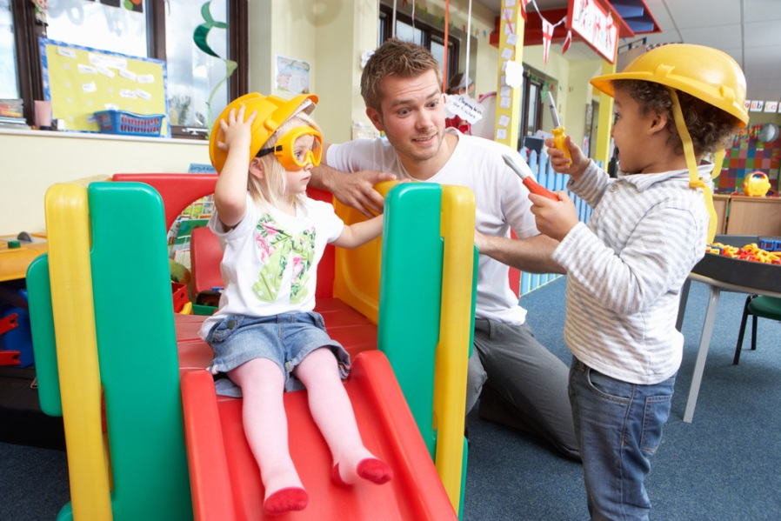

Statutory requirements in the Early Years.

*Early Years Foundation Stage Statutory Guidance 2017 states that:*

Every child deserves the best possible start in life and the support that enables them to fulfil their potential. Children develop quickly in the early years and a child’s experiences between birth and age five have a major impact on their future life chances. A secure, safe and happy childhood is important in its own right. Good parenting and high quality early learning together provide the foundation children need to make the most of their abilities and talents as they grow up.

There are seven areas of learning and development that must shape educational programmes in Early Years settings. All areas of learning and development are important and inter-connected.

**Communication and language** development involves giving children opportunities to experience a rich language environment; to develop their confidence and skills in expressing themselves; and to speak and listen in a range of situations.

• **Physical development** involves providing opportunities for young children to be active and interactive; and to develop their co-ordination, control, and movement. Children must also be helped to understand the importance of physical activity, and to make healthy choices in relation to food.

• **Personal, social and emotional development** involves helping children to develop a positive sense of themselves, and others; to form positive relationships and develop respect for others; to develop social skills and learn how to manage their feelings; to understand appropriate behaviour in groups; and to have confidence in their own abilities.

• **Literacy** development involves encouraging children to link sounds and letters and to begin to read and write. Children must be given access to a wide range of reading materials (books, poems, and other written materials) to ignite their interest.

• **Mathematics** involves providing children with opportunities to develop and improve their skills in counting, understanding and using numbers, calculating simple addition and subtraction problems; and to describe shapes, spaces, and measures.

• **Understanding the world** involves guiding children to make sense of their physical world and their community through opportunities to explore, observe and find out about people, places, technology and the environment.

• **Expressive arts and design** involves enabling children to explore and play with a wide range of media and materials, as well as providing opportunities and encouragement for sharing their thoughts, ideas and feelings through a variety of activities in art, music, movement, dance, role-play, and design and technology.

For children whose home language is not English, providers must take reasonable steps to provide opportunities for children to develop and use their home language in play and learning, supporting their language development at home. Providers must also ensure that children have sufficient opportunities to learn and reach a good standard in English language during the EYFS: ensuring children are ready to benefit from the opportunities available to them when they begin Year 1. When assessing communication, language and literacy skills, practitioners must assess children’s skills in English. If a child does not have a strong grasp of English language, practitioners must explore the child’s skills in the home language with parents and/or carers, to establish whether there is cause for concern about language delay.

In planning and guiding children’s activities, practitioners must reflect on the different ways that children learn and reflect these in their practice. Three characteristics of effective teaching and learning are:

• **Playing and exploring** - children investigate and experience things, and ‘have a go’;

• **Active learning** - children concentrate and keep on trying if they encounter difficulties, and enjoy achievements; and

• **Creating and thinking critically** - children have and develop their own ideas, make links between ideas, and develop strategies for doing things.

Assessment plays an important part in helping parents, carers and practitioners to recognise children’s progress, understand their needs, and to plan activities and support. Ongoing assessment (also known as formative assessment) is an integral part of the learning and development process. It involves practitioners observing children to understand their level of achievement, interests and learning styles, and to then shape learning experiences for each child reflecting those observations. In their interactions with children, practitioners should respond to their own day-to-day observations about children’s progress and observations that parents and carers share.

**Progress check at age two**

When a child is aged between two and three, practitioners must review their progress, and provide parents and/or carers with a short written summary of their child’s development in the prime areas of learning. This progress check must identify the child’s strengths, and any areas where the child’s progress is less than expected. If there are significant emerging concerns, or an identified special educational need or disability, practitioners should develop a targeted plan to support the child’s future learning and development, involving parents and/or carers and other professionals (for example, the provider’s Special Educational Needs Co-ordinator or health professionals) as appropriate.

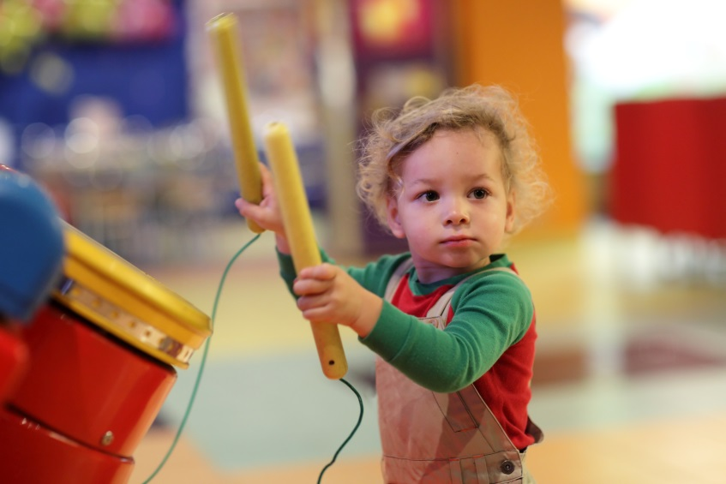

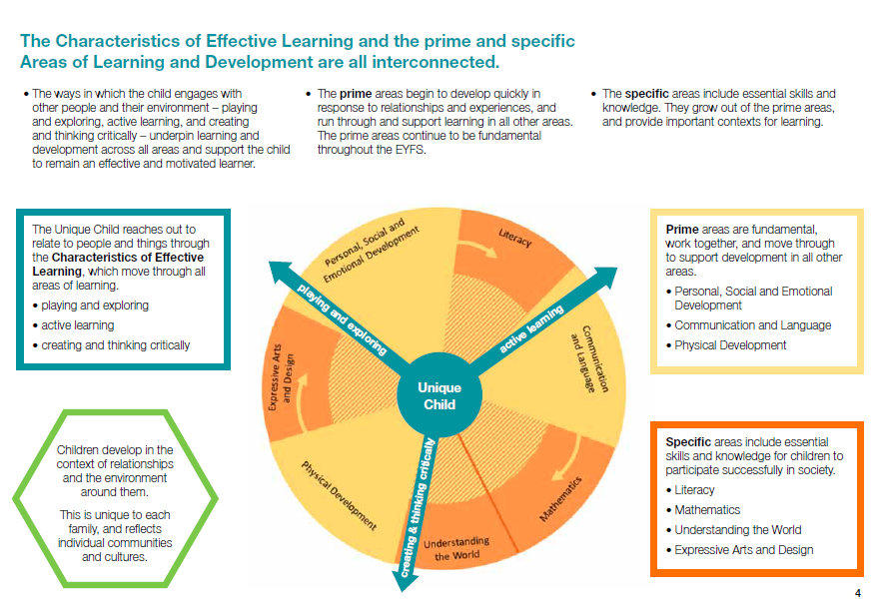

UN convention on the Rights of the Child.

In 1989, governments across the world promised all children the same rights by adopting the UN Convention on the Rights of the Child. The Convention says what countries must do so that

all children grow as healthy as possible, can learn at school, are protected, have their views listened to, and are treated fairly.

**Article 2**

The Convention applies to everyone: whatever their race,

religion or abilities, whatever they think or say, whatever type of

family they come from.

**Article 12**

Every child has the right to have a say in all matters affecting

them, and to have their views taken seriously.

**Article 23**

A child with a disability has the right to live a full and decent

life with dignity and independence, and to play an active part in

the community. Governments must do all they can to provide

support to disabled children.

**Article 29**

Education must develop every child’s personality, talents and

abilities to the full. It must encourage the child’s respect for

human rights, as well as respect for their parents, their own and

other cultures, and the environment.

**Article 30**

Every child has the right to learn and use the language, customs

and religion of their family, regardless of whether these are

shared by the majority of the people in the country where they

live.

**Article 31**

Every child has the right to relax, play and take part in a wide

range of cultural and artistic activities.

In order to fulfil statutory requirements best practice needs have regard to all of the above points. Best practice could include the following:

**Best practice to support young children's development of speech, language and communication**

Good practice in the observational assessment of children who are learning English is good practice for the assessment of all children.

Assessment must distinguish between a child’s English language acquisition and their development of knowledge and concepts across the six areas of learning, as outlined in the *Curriculum guidance for the foundation stage*.

Assessment of education provision

In making assessment judgements about the progress of children over time, it is crucial also to evaluate the impact of the setting’s education provision and teaching methods.

Here are some key points to consider.

1. Are the home languages of children reflected in the displays that celebrate their multilingual identities and cultural experiences?

2. Do curriculum resources reflect a multinational perspective or are they Eurocentric in images and content, to the point of unwitting bias and exclusion?

3. Are the learning contexts and social groupings enabling or intimidating?

4. Are key words from the child’s home language used to foster a sense of belonging and achievement in knowing more than one way of speaking?

5. Is the power of visual, auditory and kinaesthetic opportunity exploited in all areas of the foundation stage curriculum to benefit all learners?

6. Are all staff aware of, and sensitive to, the need for process time for children, as they manage the new compositional challenges of thinking and talking in a new language with new vocabulary and grammar?

7. Are there activities planned that offer and extend children’s knowledge of particular forms of English usage, for example descriptive language development when taking a visual walk with a camera, expressive language when playing shops or in dramatic replay of a story, or positional language while building with blocks or planks outdoors?

8. Do practitioners track (and use as evidence) children’s developing oral competence in English by noting specific vocabulary and chunks of language that children are acquiring and using over time?

9. To avoid under-assessing a child in a particular area of learning, do practitioners consult and moderate with other early year’s colleagues in order to ensure accurate judgements?

10. Does the setting’s assessment procedure take account of the cultural, religious and ethnic diversity of all its children, including those learning English as an additional language, and ensure all parents’ contributions are respected, valued and used?

11. Do practitioners plan activities that encompass children’s communities’ key places, festivals, holy days, special customs and observances?

12. Are all staff aware of what may be different cultural conventions in (and expectations of) education, play/work, behaviour, self-care, and independence for boys and girls, for families learning English?

13. Are the areas of learning planned with examples of other cultures’ scripts, number systems, and traditional stories so that learning activities are meaningful and inclusive

Factors to consider when making a judgement about progress

Some children will avoid any physical contact for cultural reasons. For example,

Muslim women and girls do not shake hands. In Nepal, the head is considered sacred and even small children should not be touched on the head.

Some children may not want to eat with other pupils because they are only used to

eating with members of their own family.

Some children may seem aggressive in the playground, or may show other behavioural

patterns. This is sometimes because their English is limited and their only form of communication with their peers is non-verbal.

Some children may appear tired or uninterested due to environmental adjustments, stress or limited English skills.

Some Children will not answer unless they know the answer – an incorrect answer or a

“guess” may mean ‘losing face’.

Some children may nod their head to acknowledge you, but this does not necessarily mean that they understand you.

Some children will **smile** even if being reprimanded, as this is a gesture of respect in some cultures

Some children will avoid eye contact with teachers – in some cultures this may be a

mark of respect and does not indicate that they are not listening.

Some children may be **unfamiliar** with the **toilet arrangements** in the setting *e.g. A child might be*

*sent in nappies to avoid these difficulties*

Some cultures – particularly some Asian families – may not want to have any **contact with animals.** *There may also be sensibilities about photos, dolls etc.*

Some children may feel recorded written work is the most important part of their work, and may pay little attention to oral based activities.

Some children may be uneasy at the more liberal approach to foundation stage activities in this country. When they are used to a more formal teaching/ learning style, they need to learn how to work co-operatively and the boundaries of behaviour expected in the setting.

|  |  |
| --- | --- |
| Survival Language | Questions |
| Hello Goodbye  Yes No  Please may I have?  Thank you  May I go to the toilet?  I don’t understand  Where is the………? | Where?  Who?  What?  Which?  Do you like?  Are you?  Am I? |
| Myself Language | Assertion and negatives |
| My name  My family  Where I live  My keyworker is  My nursery/pre-school is  My friends  I like/don't like | I am/am not  I like/don't like  I want /don't want  You are/aren't  You can/can't  ….Is/isn't |
| Action verbs | Everyday nouns |
| Run  Walk  Sit  Stand  Eat  Drink  Look  Jump  Throw  Catch  Listen | In the setting:  Door  Window  Chair  Table  Toilet  Outside  Inside  Book  Snack (time)  Story (time)  Outside the setting:  Road  House  Car  Crossing  Lights |

Strategies for supporting/developing communication in English:

Self-Talk: Young preschool children frequently talk out loud to themselves as they play and explore the environment. This self-directed talk is known as private speech. Children’s private speech is used for self-direction and this language is the foundation for later complex mental activity. Also known as inner language, self-instruction or self-talk, it serves to link words, actions and ideas, and facilitates planning, critical thinking and executive functioning. Practitioners may ‘self-talk’ through activities with which they are engaged, so that they are giving children a commentary on their actions, for example ‘I’m putting the banana on the plate, now you can help me cut it’,

Parallel talk: This is where the practitioner provides a commentary on what the child is doing. This strategy can be very helpful for short periods but should not be extended to the point where it becomes intrusive or inhibiting.

Repeating: Repetition is important, not only in stories, songs and finger plays, etc., but repeating and confirming children’s own attempts at speech. By showing your interest in this way you will encourage children to continue in their attempts to speak. By repeating and adding to the child’s spoken language you will be scaffolding their language learning, consolidating and adding to their knowledge of language structure.

Modelling: This is important for introducing children to new language structures and vocabulary. Children need to hear language used in a meaningful context before they can rehearse and use it themselves. Much of this is what practitioners and parents will do naturally to encourage children’s language learning. It is important to be encouraging without being demanding and to use modelling to correct mistakes rather than tell children they are wrong – this will only serve to inhibit their attempts and damage self-esteem.

Open ended questions: Use Open ended questions such as ‘Why is he crying?’ to provide opportunity to use language extensively.

**Appendix 1**

|  |  |  |  |
| --- | --- | --- | --- |
|  | **Observations of EAL Development** | **EYFS Reference** | **Suggested Practitioner Strategies** |
| **Step 0 New to English** | Is using their home language to interact with others. |  | Set up a home communications link, bilingual when possible.  Encourage parents/carers to participate  Provide support in terms of gestures, use of home language and visuals to aid understanding.  Where possible have a bilingual assistant.  Learn and teach the class some phrases, numbers 1-10 and some keywords in child’s home language  Watch children carefully to interpret their gestures and put words to them  Give children plenty of time to express their needs  Model speech for child, model back what they say & extend it.  Ensure environment reflects cultural diversity  Support children in joining in activities, giving them key words and phrases to take part ( thanks, my go etc.)  Plan to enable children to join in story telling with story props  Always praise and reward any kind of effort.  Encourage child to indicate when they can’t understand  Use communications fans ([www.breazshare.net](http://www.breazshare.net))  *Provide dual language books for children*  *Display different language print in role-play areas* |
| Is usually silent and receptive (The Silent Period) |  |
| U Uses non-verbal gestures to respond to greetings and questions. | (U) 8-20 CL |
| Observes other children and imitates their words / sounds | (S )/ 8-20 CL |
| Is interested in watching other children. | PSE 8-20 |
| Is able to join small group time activities for a short period of time. | (LA) 8-20 CL |
| Is beginning to use single words to express needs i.e. toilet, mummy etc. | (U)/ 8-20 CL |
| Beginning to create and use personal / home language words as their language develop | (S) 8-20 CL |
| Understanding words in context, snack time, sit down. | (U) 8-20 CL |
| Uses eye pointing to make request and to communicate. | (S) 8-20 CL |
| Can copy some words when they are modelled | (S) 16-26 CL |
| Points to named body parts when asked. | 8- 20 PSE |
| Beginning to understand `yes` and `no` and some boundaries. |  |
| **Step 1 Beginner Bilingual** (a little access to the curriculum) )through English) | Is uses their home language to express needs. | (S) 16- 26CL | Where possible use songs and stories in the child’s home language  Keep carpet sessions short  Encourage children to bring in familiar objects from home for show and tell.  Model language in the home corner  Provide activities for parents/carers to do at home in the home language that will support concept development.  Work closely with the family, and use interpreters when needed.  Have words/phrases of the week in the child’s home language  Allow extra time for response  Engage children appropriately during carpet sessions, prevent them from getting into the habit of switching off by holding up visuals and prompts.  Expand children’s language, e.g. Child: *‘I play car.’* You could say, *‘Yes you are playing with the car”*  *Please, thank you, banana, go, hot etc.* |
| Can select and name some common objects- car, bag, doll … | (U) 16-26 CL |
| Pays attention to and responds to familiar instructions ( sit down, outside everyone) | (U) 16 -26CL |
| Enjoys and joins in repetitive stories, songs and action rhymes. | (LA) 22-36 L |
| Shows an interest in exploring different sounds and rehearsing words. | (LA) 22-36CL |
| Uses home language to talk to others. | 22-36 PSE |
| Understands simple sentences, `Throw the ball`  . | (U) 16-26 CL |
| Is beginning to put two words together. | (S) 16-26 CL |
| Counts to 3 in imitation | 22-36 M |
| Uses different types of everyday words. | (S) 16-26 CL |
| Recognises and responds to familiar sounds, i.e. tidy up song | (LA) 22-36CL |
| **Step 2 Early Bilingual** (Some access to the curriculum through English)Re | Will sometimes use home language to express feelings and needs. | 22-36 PSE | Make children feel proud of being bilingual; give status to ability to speak in two languages  Model and extend the speech the child is using  Create opportunities to speak in carefully structured situations (e.g.: snack time routines- would you like an apple?)  Reflect back single words and short chunks/phrases so if the child says *bird tree*, say *is the bird in the tree?, can you see the bird in the tree?*  Repeat new vocabulary lots of times through using the same objects/words in different contexts, games, song etc.  Model and encourage role-play that builds on familiar contexts.  Where possible before introducing new stories send home stories in home language.  Use simple stories with clear visuals and lots of repetition  Encourage children to share books with a good role model or friend. Talk about the pictures/text. Respond to what the child is interested in.  Point and name objects, colours etc. in the books.  Play pelmanism, snap track games to introduce and consolidate new words.  Teach the whole group songs, rhymes and action stories in the child’s home language ( ask parents/carer to help you)  Use CD's to provide extra listening experience of language already heard in stories and songs.  Use CD’s in other languages  Model language patterns in a range of functions, e.g. *news telling, feely bags, circle games* and ensure they are revisited every day with opportunities for children to join in.  Celebrate confident talk, e.g. ‘*You explained that*  *really well”* |
| Is beginning to use a small range of familiar phrases or expressions to their play | (S) 16-26 CL |
| Uses familiar phrases of 3-4 words | (S) 22-36 CL |
| Beginning to ask simple questions | (S) 16-26 CL |
| Will listen with interest and try copy talk that is modelled for them. | (LA) 22-36CL |
| Takes part in play with other children in a small group. | 22-36 PSE |
| Uses the appropriate language to retell parts of stories with the help of props | (S) 22-36 CL |
| Repeats words and phrases form familiar stories. | (R) 22-36 L |
| Uses simple sentences of 2-3 words. | (S) 22-36 CL |
| Beginning to use word endings for plurals. | ( S) 22-36CL |
| Uses a widening vocabulary from stories. | ( R)30-50 L |
| Recognises own name, and other print in the environment. | ( R )30-50 L |
| Listens and joins in with action stories and rhymes and is able to echo repetitive phrases in stories. | (R )30-50 L |
| Listens to other 1.1 or in small groups. | (LA )30-50CL |
| Begins to use negative forms (I don’t like it, he’s not big) |  |
| Beginning to use pronouns such as *me & him* |  |
| **Step 3 Developing Bilingual** | Initiates conversation about things that interest them or past events | (S) 30-50CL | Provide role-play activities which reflect community diversity.  Use language models through puppets, stories etc. that children can try out in the safety of the role play area.  Use tape recorders for children to record and listen to their own talk.  Use interactive computer games and encourage children to work in pairs.  Use talk partners  Have sharing sessions at carpet time  Play collaborative games  Use games to teach talk/respond sequences (e.g.: What’s the Time Mr Wolf?)  Simplify other children’s talk  Give plenty of opportunities to work with good role- models. |
| Can listen with interest to the language and tone used by adults or story character in role-play | (LA)22-36 CL |
| Takes part in a simple interaction during role play. | 22-36 PSE |
| Can use intonation to make meaning clear | (S) 30-50 CL |
| Beginning to extend what they say with gestures/ support | (S) 22-36 CL |
| Can use language to share feelings. | (S) 22-36 CL |
| Can be heard practising classroom talk, at home / setting. |  |
| Begins to use some adjectives- big/small, good/bad. | (S) 22-36 CL |
| Begins to ask simple questions using where and who.(e.g.: in the role-play shop *who’s next?)* | (S) 22-36CL |
| Listens to others and takes account of their feelings and wishes. | 22-36 PSE |
| Responds to speaker with relevance | 22-36 PSE |
| Understand when it is his /her turn to speak and gives chances to other children to speak. | 30-50 PSE |
| Confidently tries new words by repeating them during their play. | (S) 22-36 CL |
| Understands basic playground and classroom English when relating to peers. | 22-36 PSE |
| Understands *who, what* and *where* in simple questions | U 22-36CL |
| Can play in a group and follow rules, if led by adult or older children. | 30-50 PSE |
| Will listen for more than 5 minutes during regular story sessions | (LA) 26-36CL |
| **Step 4 Competent Bilingual (access to the curriculum but gaps evident)** | Is able to listen to others and keep a listeners attention, often using their voice and gesture. | (LA) 30-50CL | Provide a prop corner with a range of culturally familiar materials for free role play (use carers’ input).  Provide a range of resources for children to choose from in order to develop their own play.  Continue to support new key vocabulary using visuals  Set group challenges, e.g. an adult could enter the imaginative play in role and present a dilemma for the participants to solve.  Allow opportunities for oral rehearsal using ‘Talk Partners’. Simple barrier games, e.g. two children use the same set of differently coloured and shaped bricks to give instructions to each other to create the same structure.  Use tape recorders for children to record for others, e.g. questions or information about displays, stories.  Make their own ‘talking books’ using Clicker 5 & Too Simple Software (in home language)  Be aware that they will not be familiar with many words that other children know.  Be aware of potential vocabulary gaps, especially when storytelling, and check understanding.  Make sure children hear more detailed vocabulary in a comprehensive context, e.g. *‘roses and tulips’* instead of *‘flowers’*.  Plan to use idioms and sayings in appropriate contexts, e.g. ‘pull your socks up!’ and explain them. |
| Talks confidently about things that interest them to a range of listeners. | 30-50 PSE |
| Engages confidently in role-play with peers. | 30 -50 PSE |
| Can demonstrate that print carries meaning and that in English it is read from left to right, and top to bottom. | (R ) 30-50 L |
| Listens to stories with increasing attention and can use the vocabulary related to what they have heard. | (LA) 30-50CL |
| Is able to use some sequence language when talking through actions (now I gonna put car in water, then car like a boat..) | (S) 30-50 CL |
| Initiates conversation with familiar people, pays attention to and takes account of others’ views. | 40-60 PSE |
| Uses talk to resolve disagreements. | 40-60 PSE |
| Uses some past tenses when talking about a past experience or retelling a story. | (S )30- 50 CL |
| Retells a story with props but may still show more gaps/confusions than expected. | (S) 40-60 CL |
| Understands most instructions / interactions and explanations with visual or other support. | (U) 30-50 CL |
| Is beginning to break the flow of speech into words. | W 40-60 L |
| Can explain what has happened in a story (without props) and can predict what may  Happen next. | (S) 30-50 CL |
| Uses more complex language to link thoughts,- and, because. | (S )30-50 CL |
| **Step 5 Fluent Bilingual** | Understands the concept of prepositional language. | (U) 30- 50 CL | Plan When planning think about the use of more complex tense structures, including conditionals, e.g. *‘What could we have done if…’*.  Model new sentence structures and provide opportunities for pupils to use them, encourage pupils to act out new structures or use them during circle time.  Plan activities where pupils have to use language in more demanding contexts, e.g. *to negotiate, disagree politely, express and justify opinions*. Model appropriate language e.g. ‘*I think ......* *because ......’*  Compare different ways of saying things for different purposes/audiences.  Use open-ended questions with pupils, and encourage them to ask each other interesting questions. |
| Shows comprehension, by describing story events and characters. | ( R ) 30-50 L |
| Uses language to and imagine and to create roles in play situations. | ( S ) 40- 60  CL |
| Language may appear comparable to that of his /her peers, reflecting their breath of experience. | (S) 30 -50 CL |
| Clarity is aided by clear stress and intonation patterns. | (S) 30-50CL |
| Increasing control of tense system to express past, future and present. | (S) 30-50 CL |
| Initiates conversations and speaks fluently and accurately about familiar topics. | 40-60 PSE |
| Uses colloquial expressions appropriately. | U |
| Explains own knowledge and understanding of stories, songs, rhymes and poems. | 40-60PSE |
| A fluent user of English who is able to take steps to resolve issues and find a compromise with peers. | 40-60 PSE |
| Uses talk to organise, sequence and clarify thinking. | (S) 40-60CL |

School EAL proficiency requirements new codes

|  |  |
| --- | --- |
| Code | Description |
| A | **New to English**  May use first language for learning and other purposes. May remain completely silent in the classroom. May be copying/repeating some words or phrases. May understand some everyday expressions in English but may have minimal or no literacy in English. Needs a considerable amount of EAL support. |
| B | **Early acquisition**  May follow day to day social communication in English and participate in learning activities with support. Beginning to use spoken English for social purposes. May understand simple instructions and can follow narrative/accounts with visual support. May have developed some skills in reading and writing. May have become familiar with some subject specific vocabulary. Still needs a significant amount of EAL support to access the curriculum. |
| C | **Developing competence**  May participate in learning activities with increasing independence. Able to express self orally in English, but structural inaccuracies are still apparent. Literacy will require ongoing support, particularly for understanding text and writing. May be able to follow abstract concepts and more complex written English. Requires ongoing EAL support to access the curriculum fully. |
| D | **Competent**  Oral English will be developing well, enabling successful engagement in activities across the curriculum. Can read and understand a wide variety of texts. Written English may lack complexity and contain occasional evidence of errors in structure. Needs some support to access subtle nuances of meaning, to refine English usage, and to develop abstract vocabulary. Needs some/occasional EAL support to access complex curriculum material and tasks |
| E | **Fluent**  Can operate across the curriculum to a level of competence equivalent to that of a pupil who uses English as his/her first language. Operates without EAL support across the curriculum. |
| N | **Not yet assessed** |

How to identify and support EAL learners with Special Educational Needs

It is important to identify children who may need extra support due to a specific learning need. Early intervention is an effective policy for helping these children to achieve well.

Practitioners should not assume that a lack of English language is linked to a learning problem or low intelligence. However if a practitioner is unsure if there is a problem, then it is best to investigate in order to provide a timely intervention, as it could lead to difficulties becoming more challenging at a later date.

Initially the child should be assessed for their competency in their home language – by talking to parents and by observing the child for a period of time. With formative assessments, general observations, a Learning Journey, language assessments and possible video recording of the child at home (with translation by parents) the child can then be assessed against Development Matters statements. ( or Foundation Stage Profile – depending on age of the child). Some assessments can be done alongside parents so that the assessor can also see how the child responds/understands in their home language.

When assessing children it is important to rule out medical/health issues (such as hearing loss). At this stage practitioners should monitor and review the child’s learning regularly in order to identify SEN at an early stage. Children under two with SEN are usually picked up through NHS interventions unless they attend Day Nurseries where Nursery professionals will be able to assess developmental levels. Again this can still be tricky if English is not the first language. Professionals can use the Early Support programme to help them set individual targets for specific children.

Most children start in settings at age two. At age two all children have a Health Visitor check as well as a progress check, if they attend a setting. This is therefore another time when children who may have SEN as well as EAL could be identified. It is important that staff work closely with parents at this stage to get their view on the child’s development.

The other assessment point when children’s development progress is clearly stated to parents is when the EYFSP is completed at the end of Reception year. This is another point when EAL children could be identified as having SEN. It must be remembered that most Early Learning Goals can be assessed in the child’s home language, EXCEPT for Communication and Language, and Literacy.

Importance of measuring *progress* in EAL children - The EAL child learns school routines, rules, vocabulary etc. very quickly, therefore the extent of their language differences changes rapidly. A failure to *make progress* in functional language is an indicator of SEN difficulties.

*Confidence* in using English and new words is also an indicator of language acquisition. Conversely, lack of confidence may indicate a difficulty with language.

Quality language stimulation is vital. Oxford has many international families, some very culturally different to UK, other European ones may appear more similar. A stimulating linguistic home-life is important to *all* children (whether English-speaking, EAL, SEN or normally-developing). Normal advice for language stimulation (talk to your baby, action songs, simplified instructions, stories etc.) applies to EAL families just as it does to English-speaking families.

When is a child with English as an additional Language not a concern with regard to Special Educational Needs:

From ECAT (Every Child A Talker)

* Children with EAL may speak their home language to staff and other children while they are in the Early Years setting. This is part of finding out that different languages exist.
* Children learning EAL may mix two languages in one sentence. This is part of the learning process and should decrease over time.
* Children may go through a silent period before they feel confident to use English. This can last up to a couple of months
* Children may go through a period of not wanting to use their home language. This may be due to the influence of peers, the dominance of the majority culture or a change in the way that the community or family use their home language.

**Appendix 2**

Case studies

Brief description - Ravensthorpe Community Childcare and Kirklees Local Authority work with families, who speak English as an additional language; to support the pre-school children’s development of early language and literacy skills in the pre-school setting and at home and to

Improve adult's employability.

*'this work with families is successful because there is a clear sense of purpose, the focus is on families learning together and that the project is supported by the community centres, well-trained and qualified staff'* <https://www.gov.uk/government/publications/helping-children-and-families-use-english-as-an-additional-language>

Ofsted inspection quotes

* There are excellent arrangements to ensure children with English as an additional language are supported. For example, staff and parents have trained together in using sign language and staff regularly uses key words in children's additional languages to communicate. This joined up learning strategy, has been planned so that children can really benefit from being able to use this valuable skill at nursery and at home, with knowledgeable staff and parents. All resources are presented at a low level in designated areas, and labelled using words and photographs.
* Staff make good observations of children's achievements and they know every child well. This helps them to plan a wide range of thought-provoking activities and deliver them very effectively. For example, staff immerse children in familiar phrases spoken in French as they share a 'French breakfast' together. Children quickly transfer their understanding of language from everyday routines, such as handwashing or spreading butter, from English into French. They learn to count and follow instructions, and they remember and use simple phrases in French. Staff provide plentiful opportunities for children to gain confidence in voicing their ideas and practise speaking in a small group.
* Staff draw on their excellent qualifications and wealth of experience. They use this to develop very positive strategies to support those children learning English as an additional language. Staff work with parents exceptionally well, to provide a consistent and very effective approach to children's care and learning. This promotes children's emotional well-being highly successfully.

Improvements needed

|  |
| --- |
| * Further support children who speak English as an additional language to see visual references to their home language, and incorporate this within their play and learning. * Some staff do not find out about words children may use at home when English is an additional language * Provide opportunities for children whose home language is not English to use photographs or labels, for example, in hand washing and toilet routines to reinforce their understanding and learning. |

Frequently asked questions:

Do children learning more than one language become confused?

*Generally this is not the case, although it is helpful if each language being learnt is used consistently. Young children have an innate skill in detecting patterns and structures of language, so learning two languages side by side does not cause particular problems.*

Do children whose parents speak another language automatically gain fluency in their parents’ language?

*This depends on their exposure to their parents languages, so will depend on how much time they spend with their parents when they are using their home languages.*

Are children who use more than one language clever?

*Children who have the opportunity to learn more than one language are lucky – any child developing typically has the capacity to learn more than one language providing they have sufficient exposure and interactions in the languages.*

Are children learning English at the same time as a home language delayed in their language acquisition?

*In some cases the production of first words can be a little later in toddlers (not always though). If there is a delay it would need investigating.*

Can children have a language disorder in one language but not another?

*A language disorder usually occurs in both languages which is why it is important to understand how well the child is progressing in the home language as well as English.*

Will children pick up English by just playing and interacting with children speaking English?

*This is not usually sufficient for a child to pick up English. Adult interactions and support are crucial in enabling children to learn English at a good rate.*

Is it best for children to learn English first and then a home language?

*This is not the best approach. Once English is established it can be very hard to introduce a home language after. If children are not learning their home language then they are being denied opportunities to develop their cultural and self-identity.*

Is it best for the setting to encourage parents to speak English at home, rather than their home language?

*It is beneficial for parents to continue speaking the home language with children at home. In the long run this will have a positive impact on English acquisition.*

**Books for EAL Learners**

Choose books with very little text, but which are clearly supported by strong visual impact.

The best stories, rhymes are those with repetitive or predictable story lines/refrains.

Choose books that relate to children's experiences which provide positive images and value cultural diversity.

Wordless picture books are ideal for reading in early language. They can be used to introduce new words or explore culture specific references.

Audio books can be useful alongside the hard copy of the story.

More and more books are being produced in dual language text. These are equally valuable for sharing with children who speak one language. With very simple books it is easy to make your own dual language version with the help of parents.

**Brown Bear, Brown Bear; The Very Hungry Caterpillar**

Eric Carle.

Examples of good Early Years books for EAL children.

**Spot Books** Eric Hill

**Dear Zoo**

Rod Campbell

**Peace at last**

Jill Murphy

**Handa's Surprise**

Eileen Browne

**Rosie's Walk; Titch**

Pat Hutchins

**How do I put it on; How do I eat it?**

Shigeo Watanabe

**Mr Gumpy's Outing; The shopping basket**

John Burningham

Games for Early Years EAL Learners

|  |  |
| --- | --- |
| Games | Language/Vocabulary Focus |
| Match a balloon | Colours, dice, your/my turn, throw, board, put |
| Picture Lotto/Matching pairs | Common nouns |
| Picture Snap | Common nouns |
| Sound Lotto | Common verbs and nouns |
| What belongs where? (Spectrum) | Common nouns, positional language, where? Home/in the street |
| Animal/people jigsaw puzzles | Parts of the body, clothes, animals |
| Tummy ache game | Food, like/dislike |
| Simon Says | Instructions, parts of the body |
| Size Lotto | Common nouns, language of size |
| Teddy bear opposites | Front, back, push, pull, over, under etc.… |
| Guess who? | Physical descriptions, clothes |
| The shopping list game | Common supermarket items |
| Picture dominoes | Common nouns |
| What's in the bag? | Any set of objects, e.g. animals, vehicles, food |

Useful links

<https://www.thecommunicationtrust.org.uk/resources/resources/resources-for-parents/misunderstood/>

<http://www.ican.org.uk/en/sitecore/content/ICAN2/Global/Content/Audience%20Menu/Practitioners.aspx>

<http://www.naldic.org.uk/eal-teaching-and-learning/outline-guidance/eal-ofsted/>

[Supporting children learning English as an additional language. Guidance for practitioners in the Early Years Foundation Stage](https://www.google.co.uk/url?sa=t&rct=j&q=&esrc=s&source=web&cd=1&ved=0ahUKEwjqltzA5JfUAhWMDcAKHVw-C0QQFggiMAA&url=https%3A%2F%2Fwww.naldic.org.uk%2FResources%2FNALDIC%2FTeaching%2520and%2520Learning%2Fealeyfsguidance.pdf&usg=AFQjCNGg_4fNJyDAychFBi2dAyjXHOx0Aw)

[The inspection of EAL under the revised framework, Mark Sims HMI, Headteachers’ Conference](http://www.google.co.uk/url?sa=t&rct=j&q=&esrc=s&source=web&cd=8&cad=rja&uact=8&ved=0ahUKEwiOmt777JfUAhVnJcAKHUaiDrkQFghIMAc&url=http%3A%2F%2Fwww.collaborativelearning.org%2FmarksimsEAL.pdf&usg=AFQjCNFwvj5Cz-jmwlOw9F8CygW0UnqhRQ)

[Norfolk, Friday 22 January 2016](http://www.google.co.uk/url?sa=t&rct=j&q=&esrc=s&source=web&cd=8&cad=rja&uact=8&ved=0ahUKEwiOmt777JfUAhVnJcAKHUaiDrkQFghIMAc&url=http%3A%2F%2Fwww.collaborativelearning.org%2FmarksimsEAL.pdf&usg=AFQjCNFwvj5Cz-jmwlOw9F8CygW0UnqhRQ)

Have you seen Oxfordshire’s SEN local Offer?

<https://www.oxfordshire.gov.uk/cms/public-site/special-educational-needs-and-disability-local-offer>

Have you seen the EY SEN web pages? <https://www.oxfordshire.gov.uk/cms/public-site/sen-support-providers>

The Bell Foundation, EAL Assessment Framework <https://www.bell-foundation.org.uk/eal-programme/teaching-resources/eal-assessment-framework/>

Nassea Assessment Framework <http://nassea.org.uk/2017/02/27/eal-assessment-framework/>

Oxfordshire Schools Inclusion Team(OXSIT) <http://www.oxsit.org.uk/>

Other useful resources

The EAL Teaching book, Jean Conteh <https://us.sagepub.com/en-us/nam/the-eal-teaching-book/book250706>

Assessing Proficiency in English for pupils with EAL by Hounslow Language Service

<http://www.ealhls.org.uk/product/p9-assessing-proficiency-in-english-for-pupils-with-eal/>

References:

Reducing Educational Disadvantage: A strategic approach in the Early Years, Penny Tassoni, Featherstone Publication 2016

EAL in the Early Years – Hundreds of ideas for supporting children with English as an Additional Language, Anita Soni, Featherstone Publication 2013

We would like to acknowledge Sue Sharp, Improvement Advisor (Early Years), Herefordshire Council, whose documents were referred to during the preparation of this guidance.