Early Years Maths Audit
The purpose of this audit is to help practitioners to develop their understanding and practice for the Specific Area of Maths.
For environments to be mathematically rich and to impact on children’s learning, they must be interactive, inclusive, usable, organised and changeable.
To achieve this, practitioners need to look at the environment through ‘a child’s eyes’.

Name of setting…………………………………………………
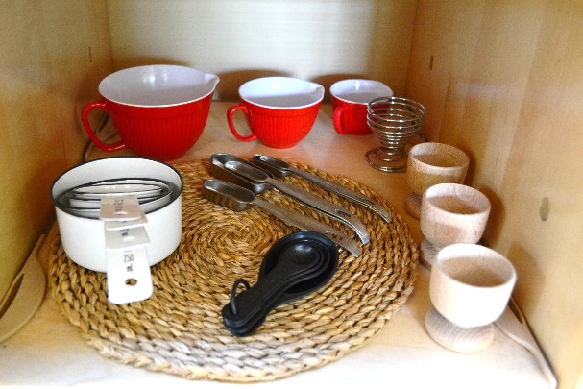
Person completing audit………………………………………
Date started……………………………………………………..
Date revisited…………………………………………………..
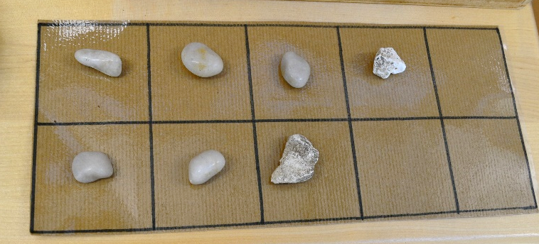
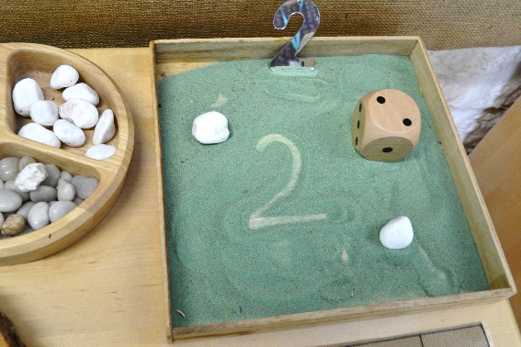

 | In place | Evidence | Actions
Staff knowledge and attitudes
There is a shared understanding of how children develop mathematically amongst the staff – knowledge, concepts, values, importance
Mathematical development and the skills required for children to develop mathematically are communicated to parents through newsletters, displays, workshops and meetings
Everyone has a chance to be mathematical (children, parents/carers and staff)
Staff are aware of their training needs for maths and CPD opportunities are provided
Staff use every opportunity to support, model and develop mathematical language
Staff recognise mathematical opportunities in all areas of the provision
Staff model and encourage problem solving and critical thinking
Staff ensure that pictorial recording and mark making are encouraged as part of the learning process for Maths as well as for Literacy
Observation, Assessment and Planning
Staff use observation to identify what children know and show in maths
Staff use observation to note how children use their mathematical knowledge

Staff use observational assessments (can also be summative) to inform planning for (further or ongoing) mathematical development

Staff use observational assessments (can also be summative) to inform planning for mathematical development
Staff plan focused maths experiences to deepen mathematical understanding
Staff plan for an environment which supports children in making decisions about their own mathematical development
Staff plan for STEM activities and experiences (Science, Technology, Engineering and Maths) which encourage children to ask questions, investigate, make predictions and test ideas.
Staff motivate children to use maths throughout their play
Staff use every day routines to support children’s mathematical understanding and vocabulary
Inclusive practice
Staff understand cultural perspectives on maths relevant to all children currently in the setting
Staff make adaptations to ensure all children are included in mathematical experiences
Resources and interest areas are labelled, with words, pictures, numbers and/or real objects
Open ended results are acknowledged and the chance to be wrong, make mistakes and test out theories is valued
Children are actively encouraged and given time to explain their mathematical thinking to adults and children
Children’s mathematical ideas, interests and fascinations are followed up
Enabling Environments - Displays
Displays include numbers that have been typed and handwritten by both adults and children
Displays celebrate children’s achievements in mathematics
Children have opportunities to display their own mathematical mark making
Displays include numerals in the environment and in everyday life
Displays are interactive and are used to promote children’s exploration and curiosity of mathematics
Visual aids such as timetables are used effectively

Numbers are displayed in English and other languages and scripts
Numerals, words and number patterns are displayed in a meaningful way (inside and outside)
Enabling Environments - Resources
Investigation of maths is encouraged through a diverse range of resources and experiences
Mathematical resources are accessible throughout the environment, as well as within the mathematics area
Children’s ways of recording measuring (capacity, length, mass, time) using standard and non-standard methods is evident
The outdoor environment complements and extends the indoor environment regarding maths

All environments are well organised, inviting and challenging

There are resources and opportunities for maths to take place on a large and small scale
Adults encourage children to sort and match including at tidy up time
Children access resources and return them independently
Children can explore mathematics through movement, e.g. dance, obstacle courses, den-making, travelling games, construction on a large scale
Resources to encourage ordering and pattern making are available e.g. a washing line at child height so that children can peg numerals in the correct order or objects to make repeating patterns
Opportunities for mathematical mark making are available on a large and small scale both inside and outside.
Playground markings or chalked markings support mathematics e.g. shapes, numerals, tracks
Number tracks, number squares and a height chart are accessible and used.
A variety of resources and ‘targets’ to support scoring and the use of tallies, e.g. basket-ball hoops, beanbags, quoits, skittles are easily available
Story and information texts that support understanding are accessible and attention is drawn to the mathematical content in an appropriate age-related way
There is a balance between natural and
commercially produced resources to support mathematical exploration
Children access games supporting mathematical development independently e.g. lotto, snap, dominoes, track games
There are ‘collections’ of objects for children to investigate, sort, sequence, count and make patterns with, e.g. age appropriate resources, boxes, buttons, socks, coins, beads, keys.

