Teaching
as defined in the Ofsted Inspection Handbooks
“Teaching” includes interactions with children whilst playing
Are you…..
Communicating
Modelling language
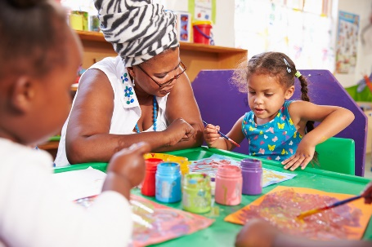
Showing
Explaining
Demonstrating
Exploring ideas
Encouraging
Questioning
Recalling
Providing a narrative
Facilitating
Setting challenges
?
…then you are teaching
It also includes the equipment, the physical environment, the structure and routines of the day, assessing what children know, understand and can do. It takes account of children’s interests and dispositions to learning in order to plan their next steps, and it monitors how well they progress
Are you doing this too??

