Counting
number
zero, one, two, three… to twenty and beyond
zero, ten, twenty… one hundred
none
how many…?
count, count (up) to
count on (from, to)
count back (from, to)
count in ones, twos… tens…
more, less, many, few
odd, even
every other
how many times?
pattern, pair
guess how many, estimate
nearly, close to, about the same as
just over, just under
too many, too few, enough, not enough
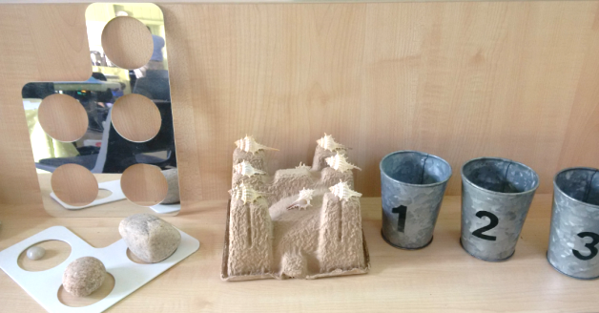

Comparing and ordering numbers
the same number as, as many as
Of two objects/amounts:
greater, more, larger, bigger
less, fewer, smaller
Of three or more objects/amounts:
greatest, most, biggest, largest
least, fewest, smallest
one more, ten more
one less, ten less
compare
order
size
first, second, third… tenth
last, last but one
before, after
next
between, above, below

Adding and subtracting
add, more, and
make, sum, total
altogether
score
double
one more, two more, ten more…
how many more to make… ?
how many more is… than…?
take (away), leave
how many are left/left over?
how many have gone?
one less, two less… ten less…
how many fewer is… than…?
difference between
is the same as

Solving problems
Reasoning about numbers or shapes
pattern
puzzle
answer
right, wrong
what could we try next?
how did you work it out?

count, sort
group, set
match
same, different
list
compare
double
half, halve
pair

General
same number/s
different number/s
missing number/s
number facts
number line, number track
number square
number cards

Problems involving 'real life' or money

compare
double, half, halve
pair
count out, share out
left, left over
money, coin, penny, pence, pound
price, cost
buy, sell
spend, spent
pay
change
dear, costs more, cheap, costs less, cheaper
costs the same as
how much…? how many…?
total

Measures (general)
measure
size
compare
guess, estimate
enough, not enough
too much, too little
too many, too few
nearly, close to, about the same as
just over, just under

Length
length, width, height, depth
long, short, tall
high, low
wide, narrow
deep, shallow
thick, thin
longer, shorter, taller, higher… and so on
longest, shortest, tallest, highest… and so on
far, near, close

Mass
weigh, weighs, balances
heavy/light, heavier/lighter, heaviest/lightest
balance, weight, scales

Capacity
full
half full
empty
holds
container

Time
time
days of the week: Monday, Tuesday…
day, week
birthday, holiday
morning, afternoon, evening, night
bedtime, dinnertime, playtime
today, yesterday, tomorrow
before, after
next, last
now, soon, early, late
quick, quicker, quickest, quickly
slow, slower, slowest, slowly
old, older, oldest
new, newer, newest
takes longer, takes less time
hour, o'clock
clock, watch, hands

Exploring patterns, shape and space
shape, pattern
flat
curved, straight
round
hollow, solid
corner
face, side, edge, end
sort
make, build, draw

3D shapes
cube
pyramid
sphere
cone

2D shapes
circle
triangle
square
rectangle
star

Patterns and symmetry
size
bigger, larger, smaller
symmetrical
pattern
repeating pattern
match

Position, direction and movement
position
over, under
above, below
top, bottom, side
on, in
outside, inside
around
in front, behind
front, back
before, after
beside, next to
opposite
apart , between
middle, edge
corner
direction
left, right
up, down
forwards, backwards, sideways, across
close, far, near
along, through
to, from, towards, away from
movement
slide
roll
turn
stretch, bend

Instructions
listen
join in
say
think
imagine
remember
start from
start with
start at
look at
point to
show me
put, place
fit
arrange
rearrange
change, change over
split
separate
carry on, continue
repeat
what comes next?
find
choose
collect
use
make
build
tell me
describe
pick out
talk about
explain
show me
read
write
trace
copy
complete
finish, end
fill in
shade
colour
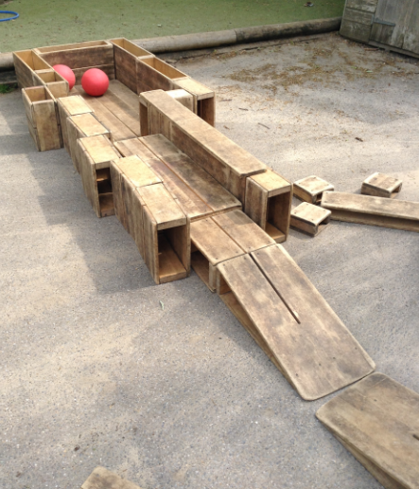
tick, cross
draw
draw a line between
join (up)
ring
cost
count
work out
answer
check

General
counters, cubes, blocks, rods
die, dice
dominoes
pegs, peg board
same way, different way
best way, another way
in order, in a different order not
all, every, each

