Musts Audit 2017/18:
Specific Early Years Foundation Stage statutory/legal requirements providers must fulfil

Please read the EYFS statutory Framework 2017 footnotes and appendix for additional information.
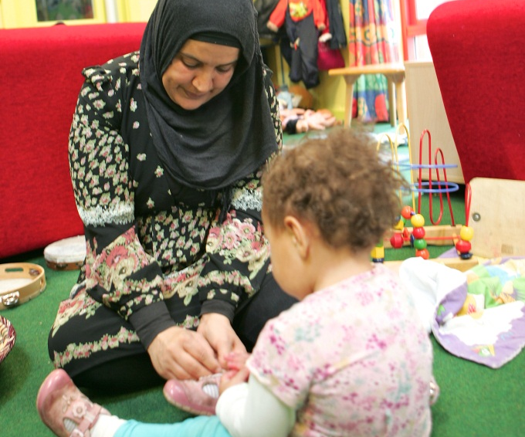
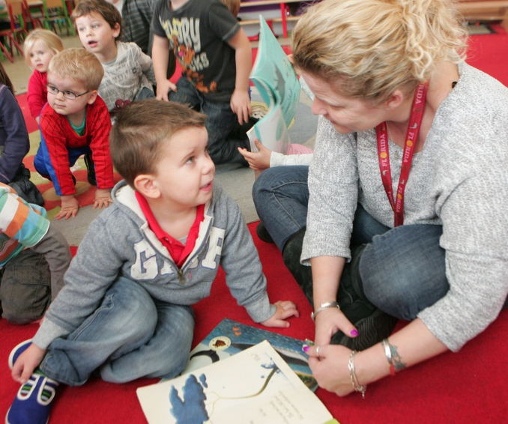
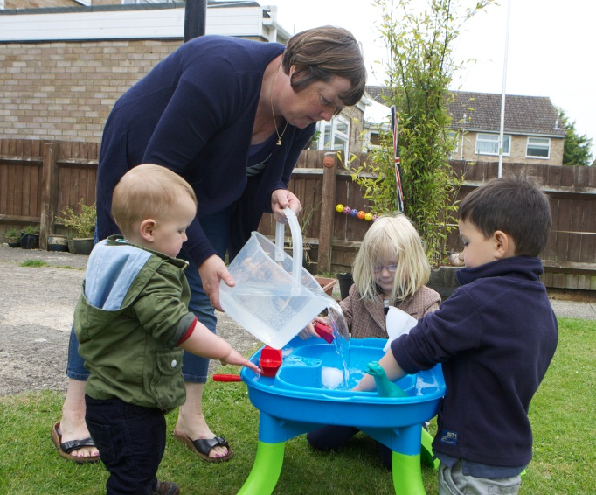

Contents
Section 1 – The Learning and Development Requirements 1
Section 2 – Assessment 5
Section 3 – The Safeguarding and Welfare Requirements 8

Section 1 – The Learning and Development Requirements
Audit of MUSTs is to be used in conjunction with the Statutory Framework for the EYFS 2017  It provides an opportunity for you to evidence and evaluate your practice in relation to the EYFS statutory Framework. |  | Review date | Location of evidence | Action required
1.1 | Providers must work in partnership with parents and/or carers, to promote the learning and development of all children in their care, and to ensure they are ready for school.
 | Early years providers must guide the development of children’s capabilities with a view to ensuring that children in their care complete the EYFS ready to benefit fully from the opportunities ahead of them.
 | Areas of Learning and Development
1.3 | There are seven areas of learning and development that must shape educational programmes in early years settings. All areas of learning and development are important and inter-connected. Three areas are particularly crucial for igniting children’s curiosity and enthusiasm for learning, and for building their capacity to learn, form relationships and thrive.  These three areas, the prime areas are:  • Communication and Language;  • Physical Development; and  • Personal, Social and Emotional Development.
1.4 | Providers must also support children in four specific areas, through which the three prime areas are strengthened and applied. The specific areas are:  - Literacy;  - Mathematics;  - Understanding the World; and  - Expressive Arts and Design.
1.5 | Educational programmes must involve activities and experiences for children, as follows.  Communication and language development involves giving children opportunities to experience a rich language environment; to develop their confidence and skills in expressing themselves; and to speak and listen in a range of situations.
 | Physical development involves providing opportunities for young children to be active and interactive; and to develop their co-ordination, control, and movement. Children must also be helped to understand the importance of physical activity, and to make healthy choices in relation to food.
 | Personal, social and emotional development involves helping children to develop a positive sense of themselves, and others; to form positive relationships and develop respect for others; to develop social skills and learn how to manage their feelings; to understand appropriate behaviour in groups; and to have confidence in their own abilities
 | Literacy development involves encouraging children to link sounds and letters and to begin to read and write. Children must be given access to a wide range of reading materials (books, poems, and other written materials) to ignite their interest.
 | Mathematics involves providing children with opportunities to develop and improve their skills in counting, understanding and using numbers, calculating simple addition and subtraction problems; and to describe shapes, spaces, and measures.
 | Understanding the world involves guiding children to make sense of their physical world and their community through opportunities to explore, observe and find out about people, places, technology and the environment.
 | Expressive arts and design involves enabling children to explore and play with a wide range of media and materials, as well as providing opportunities and encouragement for sharing their thoughts, ideas and feelings through a variety of activities in art, music, movement, dance, role-play, and design and technology.
1.6 | Practitioners must consider the individual needs, interests, and stage of development of each child in their care, and must use this information to plan a challenging and enjoyable experience for each child in all of the areas of learning and development.
 | Practitioners working with the youngest children are expected to focus strongly on the three prime areas, which are the basis for successful learning in the other four specific areas.
 | Throughout the early years, if a child’s progress in any prime area gives cause for concern, practitioners must discuss this with the child’s parents and/or carers and agree how to support the child.
 | Practitioners must consider whether a child may have a special educational need or disability which requires specialist support.
 | They should link with, and help families to access, relevant services from other agencies as appropriate.
1.7 | For children whose home language is not English, providers must take reasonable steps to provide opportunities for children to develop and use their home language in play and learning, supporting their language development at home.
 | Providers must also ensure that children have sufficient opportunities to learn and reach a good standard in English language during the EYFS.
 | When assessing communication, language and literacy skills, practitioners must assess children’s skills in English.
 | If a child does not have a strong grasp of English language, practitioners must explore the child’s skills in the home language with parents and/or carers, to establish whether there is cause for concern about language delay.
1.8 | Each area of learning and development must be implemented through planned, purposeful play and through a mix of adult-led and child-initiated activity.
 | Practitioners must respond to each child’s emerging needs and interests, guiding their development through warm, positive interaction.
1.9 | In planning and guiding children’s activities, practitioners must reflect on the different ways that children learn and reflect these in their practice. Three characteristics of effective teaching and learning are:  • Playing and Exploring - children investigate and experience things, and ‘have a go’;  • Active Learning - children concentrate and keep on trying if they encounter difficulties, and enjoy achievements; and  • Creating and Thinking Critically - children have and develop their own ideas, make links between ideas, and develop strategies for doing things.
1.10 | Each child must be assigned a key person (also a Safeguarding and Welfare requirement 3.27).
 | Providers must inform parents and/or carers of the name of the key person, and explain their role, when a child starts attending a setting.
 | The key person must help ensure that every child’s learning and care is tailored to meet their individual needs.
 | The key person must seek to engage and support parents and/or carers in guiding their child’s development at home.
 | They should also help families engage with more specialist support if appropriate.
1.12 | The level of progress children are expected to have attained by the end of the EYFS is defined by the Early Learning Goals (see pg. 10 – 12)

Section 2 – Assessment
Audit of MUSTs is to be used in conjunction with the Statutory Framework for the EYFS 2017  It provides an opportunity for you to evidence and evaluate your practice in relation to the EYFS statutory Framework. |  | Review date | Location of evidence | Action required
2.1 | In their interactions with children, practitioners should respond to their own day-to-day observations about children’s progress and observations that parents and carers share.
2.2 | Assessment should not entail prolonged breaks from interaction with children, nor require excessive paperwork. Paperwork should be limited to that which is absolutely necessary to promote children’s successful learning and development. Parents and/or carers should be kept up-to-date with their child’s progress and development. Practitioners should address any learning and development needs in partnership with parents and/or carers, and any relevant professionals.
 | Progress check at age 2
2.3 | When a child is aged between two and three (between 2.5 and 3 years in Oxfordshire), practitioners must review their progress, and provide parents and/or carers with a short written summary of their child’s development in the prime areas.
 | This progress check must identify the child’s strengths, and any areas where the child’s progress is less than expected. If there are significant emerging concerns, or an identified special educational need or disability, practitioners should develop a targeted plan to support the child’s future learning and development involving parents and/or carers and other professionals as appropriate.
2.4 | The summary must highlight:  Areas in which a child is progressing well; areas in which some additional support might be needed; and focus particularly on any areas where there is a concern that a child may have a developmental delay (which may indicate a special educational need or disability).
 | It must describe the activities and strategies the provider intends to adopt to address any issues or concerns.
 | Practitioners must discuss with parents and/or carers how the summary of development can be used to support learning at home.
2.5 | Practitioners should encourage parents and/or carers to share information from the progress check with other relevant professionals, including their health visitor and the staff of any new provision the child may transfer to.
 | Practitioners must agree with parents and/or carers when will be the most useful point to provide a summary. Where possible, the progress check and the Healthy Child Programme health and development review at age two should inform each other and support integrated working.
 | Providers must have the consent of parents and/or carers to share information directly with other relevant professionals.
Assessment at the end of the EYFS – the Early Years Foundation Stage Profile (EYFSP)
2.6 | In the final term of the year in which the child reaches age five, and no later than 30 June in that term, the EYFS Profile must be completed for each child.
 | The Profile must reflect: on-going observation; all relevant records held by the setting; discussions with parents and carers, and any other adults whom the teacher, parent or carer judges can offer a useful contribution.
2.7 | Each child’s level of development must be assessed against the early learning goals.
 | Practitioners must indicate whether children are meeting expected levels of development, or if they are exceeding expected levels, or not yet reaching expected levels (‘emerging’). This is the EYFS Profile.
2.8 | Year 1 teachers must be given a copy of the Profile report together with a short commentary on each child’s skills and abilities in relation to the three key characteristics of effective learning.
 | These should inform a dialogue between Reception and Year 1 teachers about each child’s stage of development and learning needs and assist with the planning of activities in Year 1.
2.9 | Schools⁷ must share the results of the Profile with parents and/or carers, and explain to them when and how they can discuss the Profile with the teacher⁸ who completed it.
 | For children attending more than one setting, the Profile must be completed by the school where the child spends most time.
 | If a child moves to a new school during the academic year, the original school must send their assessment of the child’s level of development against the early learning goals to the relevant school within 15 days of receiving a request. If a child moves during the summer term, relevant providers must agree which of them will complete the Profile.
2.10 | The Profile must be completed for all children, including those with special educational needs or disabilities.
 | Reasonable adjustments to the assessment process for children with special educational needs and disabilities must be made as appropriate. Providers should consider whether they may need to seek specialist assistance to help with this.
 | Information to be provided to the Local Authority
2.11 | Early years providers must report EYFS Profile results to local authorities, upon request. Local authorities are under a duty to return this data to the relevant Government department.
 | Providers must permit the relevant local authority to enter their premises to observe the completion of the EYFS Profile, and permit the relevant local authority to examine and take copies of documents and other articles relating to the Profile and assessments.
 | Providers must take part in all reasonable moderation activities specified by their local authority and provide the local authority with such information relating to the EYFS Profile and assessment as they may reasonably request.

Section 3 – The Safeguarding and Welfare Requirements
Audit of MUSTs is to be used in conjunction with the Statutory Framework for the EYFS 2017  It provides an opportunity for you to evidence and evaluate your practice in relation to the EYFS Statutory Framework. |  | Review date | Location of evidence | Action required
Providers must ensure that their arrangements for safeguarding children comply with current guidance from government and the Oxfordshire Safeguarding Children Board (OSCB).
The annual Early Years Safeguarding audits for Settings, Childminders and Out of School Clubs can be found on the Early Years Toolkit.
3.2 | Providers must take all necessary steps to keep children safe and well. Providers must safeguard children; ensure the suitability of adults who have contact with children; promote good health; manage behaviour; and maintain records, policies and procedures.
3.3 | All policies should be in place to cover EYFS requirements so they can be explained to parents, carers, staff and others.
 | Child Protection
3.4 | Providers must be alert to any issues for concern in the child’s life at home or elsewhere.
Providers must have and implement a policy, and procedures, to safeguard children. These should be in line with the guidance and procedures of the relevant Local Safeguarding Children Board (OSCB).
(The OSCB Early Years Safeguarding and Child protection policy includes a section on Child sexual exploitation, Forced marriages, Female genital mutilation and the Prevent duty in line with current legislation).
 | The safeguarding policy and procedures must include an explanation of the action to be taken in the event of an allegation being made against a member of staff, and cover the use of mobile phones and cameras in the setting.
3.5 | A practitioner must be designated to take lead responsibility for safeguarding children in every setting. Childminders must take the lead responsibility for themselves.
 | The lead practitioner is responsible for liaison with local authority children’s services agencies, and with the LSCB.
 | They must provide support, advice and guidance to any other staff on an ongoing basis, and on any specific safeguarding issue as required. The lead practitioner must attend a child protection training course. This must be a face to face OSCB Early Years Designated Lead.
3.6 | Providers must train all staff to understand their safeguarding policies and procedures and ensure that all staff have up to date knowledge of safeguarding issues.
Training made available by the provider must enable staff to identity signs of possible abuse and neglect at the earliest opportunity, and to respond in a timely and appropriate way.
Providers may also find ‘What to do if you’re worried a child is being abused: Advice for practitioners helpful.

3.7 | Providers must have regard to the government's statutory guidance ‘Working Together to Safeguard Children 2015’ and to the ‘Prevent duty guidance for England and Wales 2015’. All schools are required to have regard to the governments ‘Keeping Children Safe in Education 2016' statutory guidance, and other childcare providers may also find it helpful to refer to this guidance. If providers have concerns about children's safety or welfare, they must notify agencies with statutory responsibilities without delay.  If providers have concerns about children's safety or welfare, they must notify agencies with statutory responsibilities without delay. This means the LCSS, MASH or Police in emergencies.
3.8 | Registered providers must inform Ofsted or their childminding agency of any allegations of serious harm or abuse by any person living, working or looking after children at the premises.
 | Registered providers must also notify Ofsted or their childminding agency of the action taken in respect of the allegations. These notifications must be made as soon as is reasonably possible, but at the latest within 14 days of the allegation being made. (They must also notify Ofsted of the action taken within 14 days.)
 | Suitable People
3.9 | Providers must ensure that people looking after children are suitable to fulfil the requirements of their role. Providers must have effective systems in place to ensure that practitioners, and any other person who is likely to have regular contact with children, are suitable.
3.10 | Ofsted or the agency is responsible for checking the suitability of childminders, and of persons living or working on a childminder’s premises.
 | Providers other than childminders must obtain an enhanced criminal records disclosure in respect of every person aged 16 and over (see conditions).
3.11 | Providers must tell staff that they are expected to disclose any convictions, cautions, court orders, reprimands and warnings which may affect their suitability to work with children.  (This should be discussed at ongoing supervision meetings)
 | Providers must not allow people whose suitability has not been checked to have unsupervised contact with children being cared for.
3.12 | Providers other than childminders must record information about staff qualifications and the identity checks, and vetting processes (including DBS reference number, the date a disclosure was obtained and details of who obtained it).
 | For childminders the relevant information will be kept by Ofsted or the agency with which the childminder is registered.
3.13 | Providers must also meet their responsibilities under the Safeguarding Vulnerable Groups Act 2006. which includes a duty to make a referral to the DBS where a member of staff is dismissed (or would have been had they not left the setting first) because they have harmed a child or put a child at risk of harm.
 | Disqualification
3.14 | In the event of the disqualification of a registered provider, the provider must not continue as an early years provider – nor be directly concerned in the management of such provision. Where a person is disqualified, the provider must not employ that person in connection with early years provision. Where an employer becomes aware of relevant information that may lead to disqualification of an employee, the provider must take appropriate action to ensure the safety of children.
3.15 | A provider or a childcare worker may also be disqualified because they live in the same household as another person who is disqualified, or because they live in the same household where a disqualified person is employed. In these circumstances the employer should consult with Ofsted and the LADO to try and obtain a waiver.
3.16 | The provider must inform Ofsted or the childminding agency of any significant event that is likely to affect the suitability of any person who is in regular contact with children on the premises where childcare is provided.
3.17 | The provider must give Ofsted or the child minding agency the following information about themselves or any person who lives in the same household as the registered provider or who is employed in the household (see conditions)
3.18 | The information must be provided to Ofsted or the childminding agency as soon as reasonably practicable but at the latest within 14 days of the date the provider became aware of the information or ought reasonably to have become aware of it if they had made reasonable enquiries.
 | Staff taking medication/substances
3.19 | Practitioners must not be under the influence of alcohol or any other substance.
 | If practitioners are taking medication which may affect their ability to care for children, those practitioners should seek medical advice.
 | Providers must ensure that those practitioners only work directly with children if medical advice confirms that the medication is unlikely to impair that staff members’ ability to look after children properly.
 | Staff medication on the premises must be securely stored, and out of reach of children, at all times.
 | Staff qualifications, training, support and skills
3.20 | Practitioners must have appropriate qualifications, training, skills and knowledge and a clear understanding of their roles and responsibilities.
 | Providers must ensure that all staff receive induction training to help them understand their roles and responsibilities. Induction training must include information about emergency evacuation procedures, safeguarding, child protection, and health and safety issues.
 | Providers must support staff to undertake appropriate training and professional development opportunities to ensure they offer quality learning and development experiences for children that continually improves.
3.21 | Providers must put appropriate arrangements in place for the supervision of staff (support, coaching and training).
 | Supervision should foster a culture of mutual support, teamwork and continuous improvement which encourages the confidential discussion of sensitive issues.
3.22 | Supervision should provide opportunities for staff to:  - discuss any issues – particularly concerning children’s development or well-being  - identify solutions to address issues as they arise; and  - receive coaching to improve their personal effectiveness.
3.23 | The manager must hold a full and relevant Level 3 qualification and at least half of all other staff must hold at least a full and relevant level 2 qualification. http://www.education.gov.uk/eypqd/
 | In group settings the manager should have at least two years’ experience of working in an early years setting, or have at least two years’ other suitable experience.
 | There must be a named deputy who, in their judgement, is capable and qualified to take charge in the manager’s absence.
3.24 | Childminders must have completed training which helps them to understand and implement the EYFS before they can register with Ofsted or a childminding agency.
 | They must be satisfied that assistants are competent in the areas of work they undertake.
3.25 | At least one person who has a current approved paediatric First Aid certificate must be on the premises and available at all times when children are present and must accompany children on outings. The certificate must be for a full course consistent with the criteria set out in Annex A of the EYFS.
 | Childminders, and any assistant who might be in sole charge of the children for any period of time, must hold a current paediatric first aid certificate and must be renewed every three years and be relevant for workers caring for young children and where relevant, babies.
 | Providers should take into account the number of children, staff and layout of premises to ensure that a paediatric first aider is able to respond to emergencies quickly. Paediatric First Aid Training providers
 | All newly qualified entrants to the early years workforce who have completed a level 2 and/or level 3 qualification on or after 30 June 2016, must also have either a full Paediatric First aid or an emergency Paediatric First Aid certificate within three months of starting work in order to be included in the required staff:child ratios at level 2 or level 3 in an early years setting.
 | Providers should display (or make available to parents) staff Paediatric First Aid certificates or a list of staff who have a current Paediatric First Aid certificate.
3.26 | Providers must ensure that staff have sufficient understanding and use of English to ensure the well-being of children in their care. For example, settings must be in a position to keep records in English, to liaise with other agencies in English, to summon help, and to understand instructions such as those for safety of medicine or food hygiene.
 | Key Person
3.27 | Each child must be assigned a key person.
 | Staff : Child Ratio
3.28 | Staffing arrangements must meet the needs of all children and ensure their safety. Ratios must be adhered to (see paragraph 3.310 – 3.39) Providers must ensure that children are adequately supervised and decide how to deploy staff to ensure children’s needs are met.
 | Providers must inform parents and/or carers about staff deployment, and, when relevant and practical, aim to involve them in these decisions.
3.29 | The provider must be aware that those aged 17 or over may be included in ratios (and staff under 17 should be supervised at all times). Students on long term placements and volunteers (aged 17 or over) and staff working as apprentices in early education (aged 16 or over) may be included in the ratios if the provider is satisfied that they are competent and responsible.
 | Before/After school care and holiday provision
3.40 | Where the provision is solely before/after school care or holiday provision for children who normally attend Reception class (or older) during the school day, there must be sufficient staff as for a class of 30 children.
 | Providers are to determine how many staff are needed to ensure the safety and welfare of children, bearing in mind the type(s) of activity and the age and needs of the children.
Providers are to determine what qualifications, if any, the manager and/or staff should have.
(See footnote 5 at paragraph 1.1 of the EYFS for the learning and development requirements for providers offering care exclusively before/after school or during the school holidays).

 | Childminders
3.41 | At any one time, childminders may care for a maximum of six children under the age of eight. Of these six children, a maximum of three may be young children, and there should only be one child under the age of one.
 | Any care provided for older children must not adversely affect the care of children receiving early years provision.
3.43 | Childminders must obtain parents and or carers’ permission to leave children with an assistant, including for very short periods of time. For Childminders providing overnight care, the ratios continue to apply and the childminder must always be able to hear the children.
 | Health: Medicines
3.44 | The provider must promote the good health of children attending the setting.
 | They must have a procedure, discussed with parents and/or carers, for responding to children who are ill or infectious, take necessary steps to prevent the spread of infection, and take appropriate action if children are ill.
3.45 | Providers must have and implement a policy, and procedures, for administering medicines.
 | It must include systems for obtaining information about a child’s needs for medicines, and for keeping this information up-to-date.
 | Training must be provided for staff where the administration of medicine requires medical or technical knowledge.
 | Prescription medicines must not be administered unless they have been prescribed for a child by a doctor, dentist, nurse or pharmacist (medicines containing aspirin should only be given if prescribed by a doctor).
3.46 | Medicine (both prescription and non-prescription) must only be administered to a child where written permission for that particular medicine has been obtained from the child’s parents and/or carer.
 | Providers must keep a written record each time a medicine is administered to a child, and inform the child’s parents and/or carers on the same day, or as soon as reasonably practicable.
 | Health: Food and Drink
3.47 | Meals, snacks and drinks must be healthy, balanced and nutritious.
 | Before a child is admitted to the setting the provider must also obtain information about any special dietary requirements, preferences and food allergies that the child has, and any special health requirements.
 | Fresh drinking water must be available and accessible at all times.
 | Providers must record and act on information from parents and carers about a child's dietary needs.
3.48 | There must be an area which is adequately equipped to provide healthy meals, snacks and drinks.
 | There must be suitable facilities for the hygienic preparation of food for children, if necessary including suitable sterilisation equipment for babies’ food.
 | Providers must be confident that those responsible for preparing and handling food are competent to do so.
 | In group provision, all staff involved in preparing and handling food must receive training in food hygiene.
3.49 | Registered providers or the childminder agency must notify Ofsted of any food poisoning affecting two or more children.
 | Notification must be made as soon as is reasonably practicable and at least within 14 days of the incident.
 | Health: Accident or injury
3.50 | Providers must ensure there is a first aid box accessible at all times with appropriate content for use with children.
 | Providers must keep a written record of accidents or injuries and first aid treatment.
 | Providers must inform parents and/or carers of any accident or injury sustained by the child on the same day, or as soon as reasonably practicable, of any first aid treatment given.
3.51 | Registered providers or the childminding agency must notify Ofsted of any serious accident, illness or injury to, or death of, any child while in their care, and of the action taken. Notification must be made as soon as is reasonably practicable and at least within 14 days.
 | Providers must notify local child protection agencies of any serious accident or injury to, or the death of, any child while in their care, and must act on any advice from those agencies.
 | Health: Managing behaviour
3.52 | Providers are responsible for managing children’s behaviour in an appropriate way.
 | Providers must not give corporal punishment to a child.
 | Providers must take all reasonable steps to ensure that corporal punishment is not given by any person who cares for or is in regular contact with a child or by any person living or working in the premises where care is provided.
 | Providers, including childminders, must keep a record of any occasion where physical intervention is used, and parents and/or carers must be informed on the same day, or as soon as reasonably practicable
3.53 | Providers must not threaten corporal punishment, and must not use or threaten any punishment which could adversely affect a child's well-being.
Safety and suitability of premises, environment and equipment
Safety
3.54 | Providers must ensure that their premises, including overall floor space and outdoor spaces, are fit for purpose and suitable for the age of children cared for and the activities provided on the premises.
 | Providers must comply with requirements of health and safety legislation (including the fire safety and hygiene requirements)
3.55 | Providers must take reasonable steps to ensure the safety of children, staff and others on the premises in the case of fire or any other emergency, and must have an emergency evacuation procedure.
 | Providers must have appropriate fire detection and control equipment (for example, fire alarms, smoke detectors, fire blankets and/or fire extinguishers) which is in working order.
 | Fire exits must be clearly identifiable and fire doors must be free of obstruction and easily opened from the inside.
 | Smoking
3.56 | Providers must not allow smoking in or on the premises when children are present or about to be present.
 | Premises
3.57 | The premises and equipment must be organised in a way that meets the needs of children and specified indoor space requirements  - Children under two years: 3.5 m2 per child  - Two year olds: 2.5 m2 per child  - Children aged three to five years: 2.3 m2 per child
3.58 | Providers must provide access to an outdoor play area or, if that is not possible ensure that outdoor activities are planned and taken on a daily basis (unless circumstances make this inappropriate, for example unsafe weather conditions).
 | Providers must follow their legal responsibilities under the Equalities Act 2010 (guidance on Equalities Act)
3.59 | Sleeping children must be frequently checked.
 | There should be a separate baby room for children under the age of two, except in childminding settings.
 | Providers must ensure the children in the baby room have contact with older children and are moved into the older age group when appropriate.
3.60 | Providers must ensure there is an adequate number of toilets and hand basins available.
 | Except in childminding settings, there should usually be separate toilet facilities for adults.
 | Providers must ensure there are suitable hygienic changing facilities for changing any children who are in nappies and providers should ensure that an adequate supply of clean bedding, towels, spare clothes and any other necessary items is always available.
3.61 | Providers must ensure that there is an area where staff may talk to parents and/or carers confidentially, as well as an area in group settings for staff to take breaks away from areas being used by children.
3.62 | Providers must only release children into the care of individuals who have been notified to the provider by the parent.
 | They must ensure that children do not leave the premises unsupervised.
 | Providers must take all reasonable steps to prevent unauthorised persons entering the premises, and have an agreed procedure for checking the identity of visitors.
 | Providers must consider what additional measures are necessary when children stay overnight.
3.63 | Providers must carry public liability insurance.
 | Risk assessment
3.64 | Providers must ensure that they take all reasonable steps to ensure staff and children in their care are not exposed to risks.
 | Providers must be able to demonstrate how they are managing risk.
 | Providers must determine where it is helpful to make some written risk assessments in relation to specific issues, to inform staff practice, and to demonstrate how they are managing risks if asked by parents and/or carers or inspectors.
 | Risk assessments should identify aspects of the environment that need to be checked on a regular basis, when and by whom those aspects will be checked, and how the risk will be removed or minimised.
 | Outings
3.65 | Children must be kept safe while on outings.
 | Providers must assess the risks or hazards which may arise for the children, and must identify the steps to be taken to remove, minimise and manage those risks and hazards.
 | The assessment must include consideration of adult to child ratios.
3.66 | Vehicles in which children are being transported, and the driver of those vehicles, must be adequately insured.
 | Special Educational needs
3.67 | Providers must have arrangements in place to support children with SEN or disabilities.
 | Maintained nursery schools and other providers who are funded by the local authority to deliver early education places must have regard to the Special Educational Needs (SEN) Code of Practice.
 | Maintained nursery schools must identify a member of staff to act as Special Educational Needs Co-ordinator and other providers are expected to identify a SENCO.
 | Childminders are encouraged to identify a person to act as a SENCO and childminders who are registered with a childminder agency or who are part of a network may wish to share the role between them.
 | Information and records
3.68 | Providers must maintain records and obtain and share information (see details) to ensure the safe and efficient management of the setting, and to help ensure the needs of all children are met.
 | Providers must enable a regular two-way flow of information between parents and/or carers, and between providers, if a child is attending more than one setting.
 | If requested, providers should incorporate parents’ and/or carers’ comments into children’s records.
3.69 | Records must be easily accessible and available (with prior agreement from Ofsted, these may be kept securely off the premises).
 | Confidential information and records about staff and children must be held securely and only accessible and available to those who have a right or professional need to see them.
 | Providers must be aware of their responsibilities under the Data Protection Act (DPA) 1998 and where relevant the Freedom of Information Act 2000.
3.70 | Providers must ensure that all staff understand the need to protect the privacy of the children in their care as well the legal requirements that exist to ensure that information relating to the child is handled in a way that ensures confidentiality.
 | Parents and/or carers must be given access to all records about their child, provided that no relevant exemptions apply to their disclosure under the Data Protection Act (DPA).
3.71 | Records relating to individual children must be retained for a reasonable period of time after they have left the provision.
 | Information about the child
3.72 | Providers must record the following information for each child as specified:
 | full name
 | date of birth
 | name and address of every parent and/or carer who is known to the provider (and information about any other person who has parental responsibility for the child);
 | which parent(s) and/or carer(s) the child normally lives with;
 | emergency contact details for parents and/or carers.
 | Information for parents and carers
3.73 | Providers must make available to parents and/or carers information as specified:
 | how the EYFS is being delivered in the setting, and how parents and/or carers can access more information
 | the range and type of activities and experiences provided for children, the daily routines of the setting, and how parents and carers can share learning at home
 | how the setting supports children with special educational needs and disabilities;
 | food and drinks provided for children
 | details of the provider's policies and procedures (all providers except childminders must make copies available on request) including the procedure to be followed in the event of a parent and/or carer failing to collect a child at the appointed time, or in the event of a child going missing at, or away from, the setting; and
 | staffing in the setting; the name of their child’s key person and their role; and a telephone number for parents and/or carers to contact in an emergency.
 | Complaints
3.74 | Providers must put in place a written procedure for dealing with concerns and complaints from parents and/or carers.
They must keep a written record of any complaints, and their outcome.
Childminders are not required to have a written procedure for handling complaints, but they must keep a record of any complaints they receive and their outcome.
 | All providers must investigate written complaints relating to their fulfilment of the EYFS requirements and notify complainants of the outcome of the investigation within 28 days of having received the complaint.
 | The record of complaints must be made available to Ofsted or the relevant childminder agency on request.
3.75 | Providers must make available to parents and/or carers details about how to contact Ofsted or the childminder agency with which the provider is registered as appropriate, if they believe the provider is not meeting the EYFS requirements.
 | If providers become aware that they are to be inspected by Ofsted or have a quality assurance visit by the childminder agency, they must notify parents and/or carers.
 | After an inspection by Ofsted or a quality assurance visit by their childminder agency, providers must supply a copy of the report to parents and/or carers of children attending on a regular basis.
 | Information about the provider
3.76 | Providers must hold the following documentation:  contact details of the provider and any other person living or employed on the premises (this requirement does not apply to childminders),
 | contact details of anyone else who will regularly be in unsupervised contact with the children
 | a daily record of the names of the children being cared for on the premises, their hours of attendance and the names of each child's key person; and
 | their certificate of registration (which must be displayed at the setting and shown to parents and/or carers on request).
 | Changes that must be notified to Ofsted or the Childminder Agency
3.77 | All registered early years providers must notify Ofsted or the childminder agency with which they are registered of any changes as specified in the Statutory Framework (see all details)
3.78 | Where providers are required to notify Ofsted or their childminder agency about a change of person except for managers, (see 3.77, providers must give Ofsted or their childminder agency the new person's name, any former names or aliases, date of birth, and home address.
If there is a change of manager, providers must notify Ofsted or the childminder agency that a new manager has been appointed in advance, where reasonably practicable, but always within 14 days.
Committees to complete DBS/EY2 form

*Early Years Foundation Stage (2017) changes

