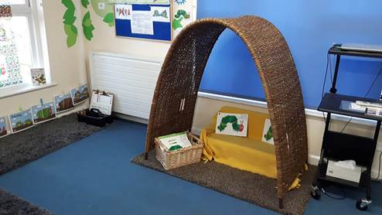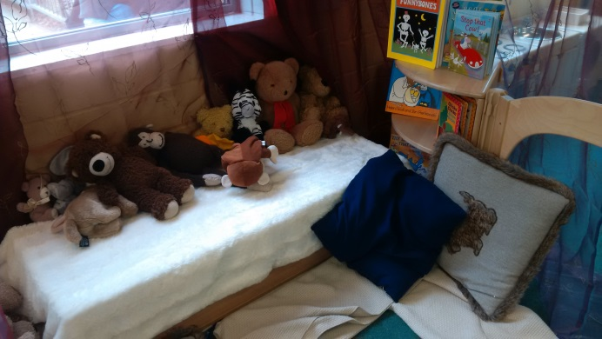

**A communication-friendly setting is about the whole environment. It is more than the building you are in or the types of resources that you provide for the children. It is also the relationships you have with families and children and the skills and knowledge you bring to ensure every child has the opportunity to become a talker**

|  |  |  |  |  |
| --- | --- | --- | --- | --- |
|  | **Good practice/Elements to consider** | **In place** | **Areas for development** | **Date completed** |
| **Role of the adult** | Practitioners:  Gather and record information from families when the child starts at the setting (Key Person)  e.g. First language, stage of language development, key words,  Share knowledge of speech and language development to work in partnership with parents  Seek specialist support if they have concerns regarding a child’s speech and language development  Use language primarily for social and learning interactions rather than to direct children and manage routines  Regularly introduce new resources/experiences to stimulate interests and communication  Plan activities to promote speech and language.  Use the child’s name to gain their attention before and during interactions  Adapt their language to the level of the child’s.  Model back correct language to the child.  Extend children’s language by adding a word.  Model words and sentences appropriately, according to children’s language development.  Ensure that new vocabulary is heard lots of times and in different situations  Encourage children to ask questions.  Comment on what children are doing as they play (rather than asking questions).  Help children to extend and develop imaginary play.  Use vocabulary children can understand when giving instructions, and check that they have understood.  Use open ended questions that invite conversation.  Give children time to respond.  Respond positively to children’s attempts to communicate, including non-verbal communication such as simple gestures, body language or signing as well as spoken language?  Use natural gesture and facial expression to accompany language.  Model activities and use of resources, and talk about what they are doing.  Respect other languages used by the child, if applicable, e.g. home language, sign language, and provide opportunities for children to use their own language.  Observe play and listen carefully before intervening.  Encourage children to talk about their own interests and draw on these interests in future interactions  Link children’s spoken and written language.  Ensure that all children have a turn at expressing themselves in a group. |  |  |  |
| **Routines** | There is time for children to settle at the beginning of a session.  There is a balance between adult-led and child-initiated learning.  Routines are flexible and enable adults to respond to different events and situations, e.g. snow, new brother/sister.  Children have sufficient time to develop and extend their own learning.  Resources are well-organised and accessible to children for a large proportion of the day.  Provide opportunities for all children to interact 1:1 with a practitioner at some point in the session.  Facilitate shared play and turn-taking.  Inform children of changes to the usual routine or environment.  Plan regular story, rhyme and singing sessions, and allow time for doing these spontaneously when children choose to |  |  |  |
| **Space, light and layout** | When speaking and listening can children see you and other children?  Staff are aware of sunlight in the room and have considered ways to ensure this does not impact on children’s ability to see practitioners faces clearly.  Space is well organised and allows children to sit and move around comfortably.  Rooms provide good light and a comfortable temperature is maintained throughout the day.  Children have access to a well-defined cosy, quiet spaces such as a book corner or a den that enables opportunities to talk to one another.  Quiet areas are less visibly distracting. |  |  |  |
| **Noise** | There are quieter areas within or near the classroom that can be used for language and communication activities, e.g. story time.  Awareness of which areas are the noisiest/quietest (e.g. toilets, cloakroom) Are there particular times of the day that are noisier or quieter than others? What can you do to minimise noise?  Is there constant noise in the setting which could be turned off e.g. music?  Awareness of auditory distractions, e.g. heater, open window  Good acoustic environment for children to listen |  |  |  |
| **Visual support/**  **resources** | The physical environment reflects the culture and ethnicity of the children in the room  Resources and activities are stimulating and at the appropriate developmental level for children  Resources are clearly labelled with pictures or symbols  Toys and resources are accessible so that children can easily reach them  Displays in the setting are child led and include children’s comments on their work. Practitioners draw children’s attention to them, and engage in ongoing conversations about the displays |  |  |  |

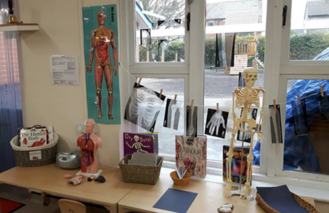 

Photographs above with kind permission of Lydalls Nursery School, Didcot